61st regular session of the Human Rights Council
Panel discussion on human rights and a culture of peace
Wednesday, 4 March 2026
BIOGRAPHIES OF PANELLISTS
Mr. Adama Dieng, African Union Special Envoy on the Prevention of Genocide and Other Mass Atrocities
and former Special Adviser of the Secretary-General on the Prevention of Genocide
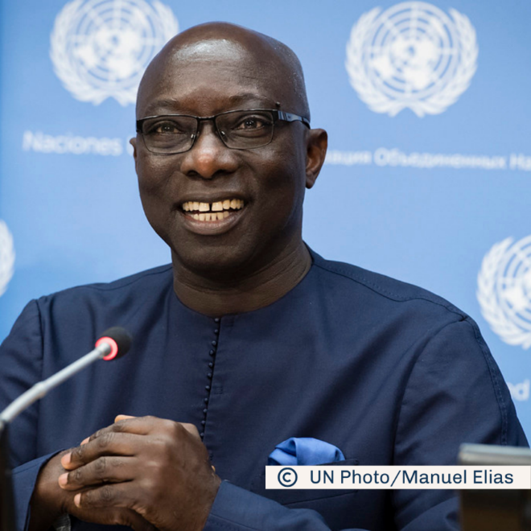 | Mr. Adama Dieng is a distinguished Senegalese jurist and one of the world’s leading voices on genocide prevention and the protection of human rights. He served as the Special Adviser of the Secretary-General on the Prevention of Genocide from 2012 to 2020, following a long career dedicated to strengthening international justice and accountability. His earlier roles include Registrar of the International Criminal Tribunal for Rwanda and Secretary-General of the International Commission of Jurists, where he advanced global legal standards and human rights protections.  Mr. Dieng has played a pivotal role in shaping African and international human rights institutions, including contributing to the establishment of the African Court on Human and Peoples’ Rights and drafting the African Convention to fight corruption. He has also served as an Independent Expert on the situation of human rights in Haiti and led numerous fact-finding missions on human rights and the rule of law.
Ms. Awa Dabo, Director and Deputy Head of the Peacebuilding and Peace Support Office (DPPA/DPO)
Ms. Awa Dabo is a seasoned United Nations leader with extensive experience in human rights, crisis recovery, peacebuilding and prevention. She currently serves as Director and Deputy Head of the Peacebuilding and Peace Support Office, where she oversees the development of peacebuilding strategies, strengthens partnerships and guides United Nations engagement in complex political and post-conflict environments.  Her career spans senior roles across the United Nations system, including Chief of Country Oversight and Support for UNDP Regional Bureau for Africa, Senior Adviser for the Crisis Bureau and UNDP Country Director in the United Republic of Tanzania. She has also worked with OCHA, OHCHR and the African Society of International and Comparative Law. Ms. Dabo began her United Nations service as a United Nations Volunteer and holds an LLM in International Human Rights Law from the University of Nottingham. | 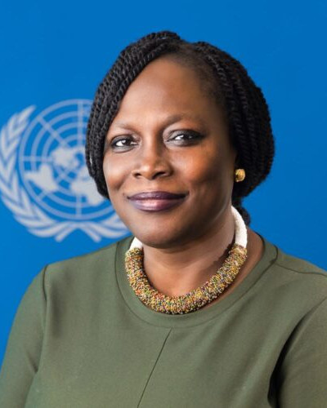
Mr. Itonde Kakoma, President and Chief Executive Officer of Interpeace
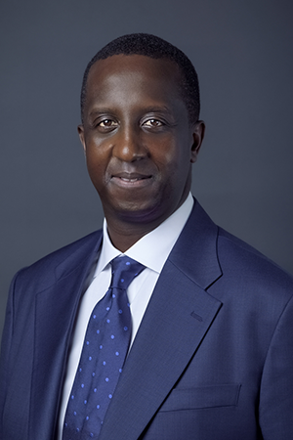 | Mr. Itonde Kakoma is an international peace mediator and humanitarian diplomat who became President and CEO of Interpeace in 2023. His career reflects extensive leadership in peace processes across Africa, the Horn of Africa and the Red Sea region. Prior to joining Interpeace, he served as the Permanent Representative of the International Federation of Red Cross and Red Crescent Societies (IFRC) to the African Union, where he advanced continental initiatives on public health security, climate resilience, disaster risk management and humanitarian affairs.  Mr. Kakoma previously held senior roles at the CMI Martti Ahtisaari Peace Foundation, directing global strategy and mediation support teams, and at The Carter Center, where he managed peace initiatives and supported high-level diplomatic efforts. His experience includes work with the Liberian Truth and Reconciliation Commission and international observation of South Sudan’s referendum on self-determination. He is recognized for his expertise in mediation, negotiation, transitional justice, and inclusive peace processes. He holds an Executive Master in International Law in Armed Conflict from the Geneva Academy.
Mr. Brett G. Scharffs, Rex E. Lee Chair and Professor of Law at Brigham Young University
and Director of the International Center for Law and Religion Studies
Professor Brett G. Scharffs is a leading scholar in law and religion, legal reasoning, and comparative constitutional law. He holds the Rex E. Lee Chair at Brigham Young University’s J. Reuben Clark Law School and serves as Director of the International Center for Law and Religion Studies. His academic career includes more than 100 publications and over 300 scholarly presentations in 30 countries, contributing significantly to global understanding of religious freedom and the rule of law.  Professor Scharffs is a graduate of Georgetown University, Oxford University (as a Rhodes Scholar) and Yale Law School. His professional background includes clerking on the U.S. Court of Appeals for the D.C. Circuit, legal work at Sullivan & Cromwell and teaching appointments at Yale University, George Washington University, Central European University and Peking University. | 