61st session of the Human Rights Council

Annual interactive debate on the rights of persons with disabilities
Theme: Disability-inclusive infrastructure, including transport and housing

BIOGRAPHIES OF SPEAKERS AND PANELLISTS
Opening statement
Mr. Volker Türk, United Nations High Commissioner for Human Rights

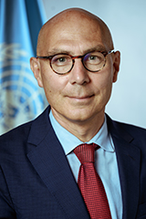
Mr. Türk is the current United Nations High Commissioner for Human Rights. He took up his official functions as High Commissioner on 17 October 2022.

He has devoted his long and distinguished career to advancing universal human rights, notably the international protection of some of the world's most vulnerable people - refugees and stateless persons.

Prior to this, Mr. Türk was the Under-Secretary-General for Policy in the Executive Office of the Secretary-General of the United Nations where he coordinated global policy work. He also ensured United Nations system-wide coordination in the follow-up to the Secretary-General’s “Call to Action for Human Rights” and his report, Our Common Agenda, which sets out a vision to tackle the world’s interconnected challenges on foundations of trust, solidarity and human rights. He previously served as Assistant Secretary-General for Strategic Coordination in the Executive Office of the Secretary-General (2019-2021).

As Assistant High Commissioner for Protection in the Office of the United Nations High Commissioner for Refugees (UNHCR) in Geneva (2015-2019), Mr. Türk played a key role in the development of the landmark Global Compact on Refugees.

Over the course of his career, he held a number of key positions including at UNHCR headquarters where he served as Director of the Division of International Protection (2009-2015); Director of Organizational Development and Management (2008-2009); and Chief of Section, Protection Policy and Legal Advice (2000-2004). Mr. Türk also served UNHCR around the world, including as Representative in Malaysia; Assistant Chief of Mission in Kosovo and in Bosnia and Herzegovina, respectively; Regional Protection Coordinator in the Democratic Republic of Congo; and in Kuwait.

Mr. Türk holds a doctorate in international law from the University of Vienna and a Master of Laws degree from the University of Linz, Austria. He has published widely on international refugee law and international human rights law. He is fluent in English and French and has a working knowledge of Spanish.

Moderator
Ms. Heba Hagrass, Special Rapporteur on the rights of persons with disabilities

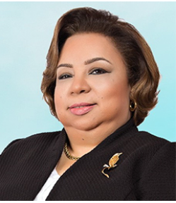
Ms. Heba Hagrass, from Egypt, was appointed by the Human Rights Council as the Special Rapporteur on the rights of persons with disabilities from 1 November 2023.
She is an advocate, an international disability consultant and a researcher on the rights of persons with disabilities with an extensive experience in Egypt, the Arab Region and worldwide. Ms. Hagrass is a sociologist with a PhD in Disability Studies at the University in Leeds (2010) with a specialization in disability rights and social policies, gender and employment.
At the international level, Ms. Hagrass was notably a representative of women with disabilities in the International Disability Caucus (IDC) who participated in the drafting of article 6 of the Convention on the Rights of Persons with Disabilities (CRPD) on women with disabilities.
From 2015 to 2020, Ms. Hagrass served as a Member of the House of Parliament of Egypt where she represented persons with disabilities. In this role, she submitted five draft laws relating to the rights of persons with disabilities covering different areas. Prior to becoming a member of parliament, she was the Secretary General of the Egyptian National Council for Disability Affairs. She is a board member of both the National Council for Persons with Disabilities and the National Council for Women. In Egypt, she was also a member of the committee drafting the National Human Rights Strategy of Egypt and a founding member of the Inclusive Education Foundation, a key advocate for starting the implementation of inclusive education in 2009.
Between 2017 and 2020, Ms. Hagrass served as a member of the Governing Council of the National African Peer Review Mechanism. Further, she is a founding member of the Arab Organization of Disabled People in 1998, where she was active until 2008, including as the head of its Women’s Affairs Committee. She was a member of the Arab Forum for Social Sciences and Health between 1997 and 2000.
Ms. Hagrass has wide experience as a consultant on disability rights and inclusion with numerous international, regional and national organizations, such as United Nations agencies, the International Disability Alliance, CBM Advisory Group, Disabled People International, Rehabilitation International, Save the Children UK, Plan Egypt, Coptic Evangelical Organization for Social Services, Arab Labor Organization and diverse Egyptian Ministries and others.

Panellists
Ms. Esther Nagetey, Youth Fellow at the International Disability Alliance

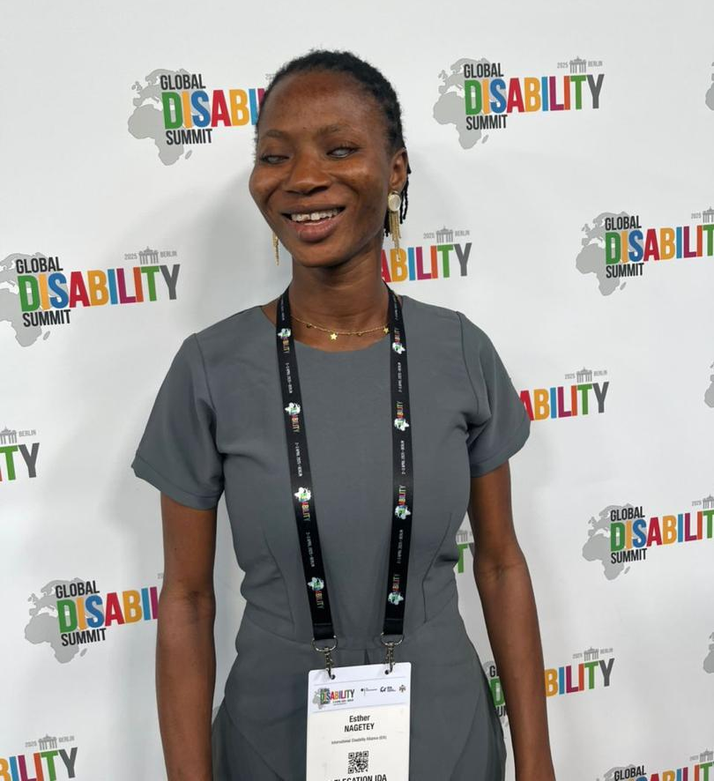
Ms. Esther Nagetey holds a Bachelor of Arts in Political Science and Philosophy from the University of Ghana and has experience working with organizations of persons with disabilities at national and regional levels.
Esther has contributed to youth leadership and disability-inclusive programmes, supported advocacy and coordination processes linked to the Convention on the Rights of Persons with Disabilities and to the Sustainable Development Goals, and engaged in intersectional initiatives promoting the rights of young women and other underrepresented groups. Her areas of expertise include youth participation, gender and disability inclusion, intersectionality and disability-inclusive advocacy and capacity-building.

Ms. Ana Vieitez, Head of Universal Accessibility at Transports Metropolitans de Barcelona

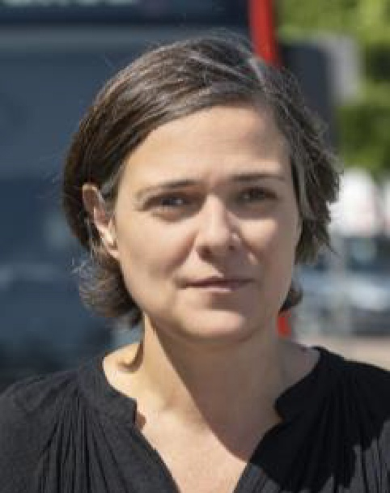
Ana Vieitez is the Head of Universal Accessibility at Transports Metropolitans de Barcelona (TMB). She is an architect specializing in universal design and accessibility, with more than two decades of experience in urban planning, public buildings and public transport systems.
Before joining TMB, Ms. Vieitez directed a consultancy focused on accessibility planning and participated in the development of national regulations related to accessible public spaces in Spain.
Since 2019, she has led TMB’s Accessibility Office, where she is responsible for the definition, coordination and implementation of the organization’s universal accessibility policies. Her functions include managing accessibility projects across metro and bus networks and coordinating processes involving public administrations, transport operators and organizations representing persons with disabilities.
Ms. Vieitez represents TMB in the International Association of Public Transport (UITP), contributing to work on inclusive mobility and the development of accessibility standards in public transport.

Ms. Natalia Ángel-Cabo, Justice of the Constitutional Court of Colombia

Natalia Angel-Cabo is a Justice of the Constitutional Court of Colombia and currently serves as its Vice President. She also presides over the Special Chamber for Monitoring Judgment T-025 of 2004, which is tasked with addressing the structural challenges of internal forced displacement in the country. In her work as a Justice, she has served as rapporteur for landmark cases on contemporary issues and global constitutionalism, including Judgments T-123 of 2024 (forced displacement and climate change), T-232 of 2024 (risks associated with transnational surrogacy), T-067 of 2025 (algorithmic transparency), T-256 of 2025 (content moderation on social media), T-105 of 2025 (ethnic groups and access to land) as well as numerous decisions in the exercise of abstract constitutional review.
Prior to joining the Constitutional Court, Justice Ángel-Cabo served as a tenured professor at the Faculty of Law of Universidad de los Andes, where she was responsible for teaching courses in constitutional law and public policy. She was the Director of the Constitutional Law Department, Editor of the Latin American Law Review and Founder and Director of the Program of Action for Equality and Social Inclusion (PAIIS), a human rights initiative focused on working with populations in situations of vulnerability. She also worked as a consultant for various national and international organizations, including the Inter-American Court of Human Rights, the World Bank, the United Nations, and the Inter-American Development Bank.
Justice Angel-Cabo is a recognized speaker at national and international universities and, in addition to RefLex, is a member and contributor to prestigious academic and judicial networks, including Yale University’s Global Constitutional Seminar, the Latin American Seminar on Constitutional and Political Theory (SELA) at Yale University, Northeastern University’s International Social and Economic Rights Project, and Stanford University’s Neukom Center for the Rule of Law.
Her academic and consulting contributions which have earned multiple distinctions span areas such as constitutional law, access to justice, participatory democracy, urban studies, and the protection of the rights of women, internally forced displaced and migrant populations, and persons with disabilities. She holds a law degree from the Faculty of Law at Universidad de los Andes and a Master of Laws (LL.M.) from Harvard University.

