62nd session of the Human Rights Council
Annual full-day discussion on the human rights of women
Panel 1: Domestic violence against women and girls
24 June 2026, 10 a.m. – 12 p.m.
BIOGRAPHIES OF SPEAKERS AND PANELISTS
OPENING STATEMENT
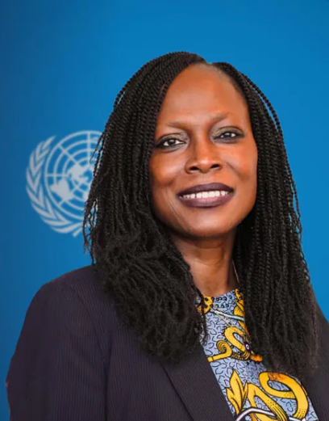
Ms. Awa Dabo
Ms. Awa Dabo is is the current United Nations Deputy High Commissioner for Human Rights. She is a human rights lawyer with extensive experience in crisis recovery, peacebuilding, transitional justice, humanitarian affairs, and development. She is currently the Deputy High Commissioner for Human Rights. Prior to this role, she held several senior positions within the United Nations, including Director and Deputy Head of the UN Peacebuilding and Peace Support Office in New York, Chief of Country Oversight and Support at UNDP’s Regional Bureau for Africa, Senior Advisor and Head of the Crisis and Fragility Policy and Engagement Team in UNDP’s Crisis Bureau, UNDP Country Director in Tanzania, and Regional Programme Manager and Team Leader with UNDP’s Bureau for Crisis Prevention and Recovery.
Ms. Dabo has worked at both headquarters and country-office levels, with experience across Africa, Asia, Latin America, the Caribbean, and Europe. During her professional career, she has worked with UN and non-UN entities, including the UN Office for the Coordination of Humanitarian Affairs (OCHA), the Office of the UN High Commissioner for Human Rights (OHCHR), the UN Department of Peacekeeping Operations (now DPO), and the African Society of International and Comparative Law.
Ms. Dabo holds a LL.M. in International Human Rights Law from the University of Nottingham (1996) and a B.A. in Law, Sociology and Social Anthropology from the University of Keele (1994).
***
PANELLISTS
Ms. Patsilí Toledo Vásquez
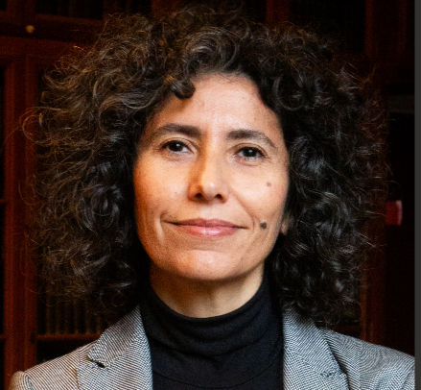
Ms. Patsilí Toledo Vásquez is a member of the UN Committee on the Elimination of Discrimination against Women (CEDAW), where she serves as Co-Chair of the Working Group on Gender-Based Violence against Women. She is a lecturer and researcher specializing in gender and criminal justice, with a particular focus on femicide and sexual violence. As a consultant, Ms. Toledo played a key role in drafting CEDAW General Recommendation No. 35 (2017) on gender-based violence against women, a landmark interpretative instrument of the Convention. She has conducted numerous studies and provided expert advice on gender and justice for international organizations, including UNODC, UN Women, and OHCHR.
Ms. Toledo holds a law degree from the University of Chile and a PhD in Public Law from the Autonomous University of Barcelona.

Ms. Ivana Krstić
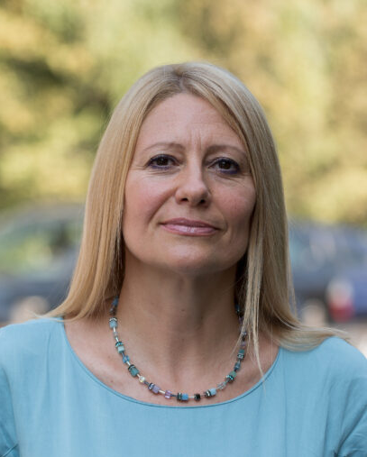
Ms. Ivana Krstić is Vice-Chair of the UN Working Group on discrimination against women and girls, having assumed her mandate in November 2023. She is a Full Professor of International Human Rights Law at the Faculty of Law, University of Belgrade, where she teaches international human rights law and related subjects. She also serves as Director of the Center for Human Rights and the Institute for Legal and Social Sciences at the Faculty of Law.
Ms. Krstić is a leading expert in gender equality and non-discrimination law, with particular expertise in violence against women, gender bias in judicial decision-making, and the implementation of international human rights standards at national level. She coordinates academic and practical initiatives supporting the implementation of the Istanbul Convention and has provided expert input to the development of anti-discrimination legislation and policies. She has worked extensively with OHCHR, UNDP, UNHCR, UNICEF, the Council of Europe, and OSCE, and is a member of the European Equality Law Network.
Ms. Krstić holds an L.L.M. from the University of Pittsburgh, an L.L.M. from the University of Belgrade, and a PhD in Law from the University of Belgrade.

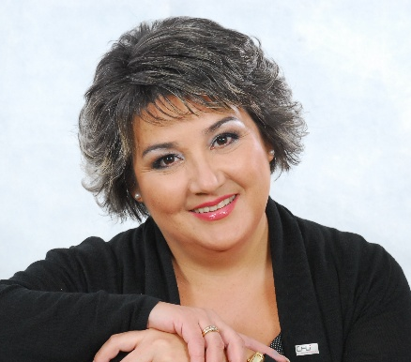
Ms. Zulfiya Baisakova
Ms. Zulfiya Mukhamedbekovna Baisakova is the Chair of the Board of the Union of Crisis Centres (Kazakhstan). She is a leading women’s rights and human rights advocate from Kazakhstan with more than two decades of experience in the prevention of domestic violence and the protection of women and girls. She currently serves as Director of the Crisis Center for Victims of Domestic Violence Municipal State Institution of the Administration of Labor and Social Programs. From 2001 to 2017, she was Chair of the Management Board of the Kazakhstan Crisis Centers Union, where she played a central role in developing a nationwide network of crisis centers and shelters for victims of domestic violence and trafficking.
Ms. Baisakova has also worked extensively as a trainer and expert on women’s rights, non-violence, and the prevention of gender-based violence in cooperation with UN Women, UNICEF, and OSCE, and has authored and co-authored numerous publications on women’s rights and social partnership.
She holds a degree in History and Law from Ust-Kamenogorsk Pedagogical Institute and completed advanced training in Management in the Non-Profit Sector at Almaty Management University.

Ms. Hyshyama Hamin
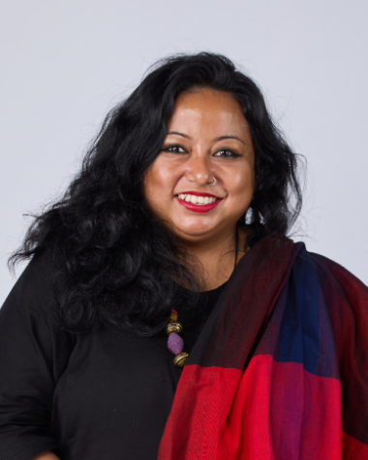
Ms. Hyshyama Hamin is the Campaign Manager of the Global Campaign for Equality in Family Law (GCEFL) and Associate Director for Economic Justice and Family Law at Equality Now. She leads the Campaign's strategic direction and coalition-building, bringing together UN agencies, international NGOs, civil society groups, and advocates in a shared mission to advance family law reform at the global, regional, and national levels. Based in Sri Lanka, Ms. Hyshyama draws on more than 15 years of experience in women's rights, including community-based research on gender-based violence and the impact of discriminatory laws and policies on women and girls.
Ms. Hyshyama is Fulbright scholar and Sié Fellow. She holds a M.A. in International Human Rights at Josef Korbel School of International Studies, University of Denver.

