61th session of the Human Rights Council
Annual high-level panel discussion on human rights mainstreaming
Theme: Role of new and emerging digital technologies in
preventing and eliminating female genital mutilation
23 February 2026

BIOGRAPHIES OF SPEAKERS AND PANELISTS

OPENING STATEMENTS

Mr. Volker Türk
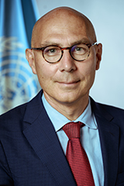
Mr. Türk is the current United Nations High Commissioner for Human Rights. He took up his official functions as High Commissioner on 17 October 2022.
He has devoted his long and distinguished career to advancing universal human rights, notably the international protection of some of the world's most vulnerable people - refugees and stateless persons.
Prior to this, Mr. Türk was the Under-Secretary-General for Policy in the Executive Office of the United Nations Secretary-General where he coordinated global policy work. He also ensured United Nations system-wide coordination in the follow-up to the Secretary-General’s “Call to Action for Human Rights” and his report, Our Common Agenda, which sets out a vision to tackle the world’s interconnected challenges on foundations of trust, solidarity and human rights. He previously served as Assistant Secretary-General for Strategic Coordination in the Executive Office of the Secretary-General (2019-2021).
As Assistant High Commissioner for Protection in the Office of the United Nations High Commissioner for Refugees (UNHCR) in Geneva (2015-2019), Mr. Türk played a key role in the development of the landmark Global Compact on Refugees.
Over the course of his career, he held a number of key positions including at UNHCR headquarters where he served as Director of the Division of International Protection (2009-2015); Director of Organizational Development and Management (2008-2009); and Chief of Section, Protection Policy and Legal Advice (2000-2004). Mr. Türk also served UNHCR around the world, including as Representative in Malaysia; Assistant Chief of Mission in Kosovo and in Bosnia and Herzegovina, respectively; Regional Protection Coordinator in the Democratic Republic of the Congo; and in Kuwait.
Mr. Türk holds a doctorate in international law from the University of Vienna and a Master of Laws degree from the University of Linz, Austria. He has published widely on international refugee law and international human rights law. He is fluent in English and French and has a working knowledge of Spanish.

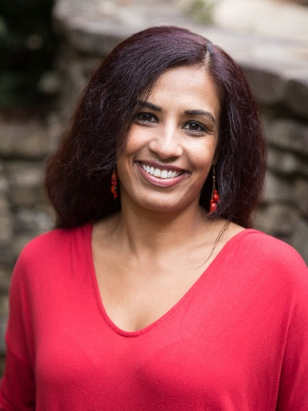
Ms. Mariya Taher
Mariya Taher is an award-winning social activist and leading expert on female genital mutilation (FGM) with nearly fifteen years of experience addressing gender-based violence through research, policy development, program design, teaching, and direct service. She is the Co-Founder and U.S. Executive Director of Sahiyo, a leading transnational organization established in 2015 to empower Asian and other communities to end FGM through dialogue, storytelling and collaboration based on community involvement.
Ms. Taher has been a driving force in elevating FGM as a national policy issue in the United States of America. She served on the steering committee of the U.S. End FGM/C Network and has supported the passage of FGM-related legislation in multiple states, including Massachusetts and Washington. She also served as an expert consultant for the U.S. Department of Justice Office for Victims of Crime’s 2021 “Addressing Female Genital Mutilation/Cutting” technical assistance project.
Her leadership has been recognized through numerous honors, including the 2018 Human Rights Storytellers Award, a 2020 Crave Foundation for Women grant, selection as a 2023 Valor LEAP Fellow, and recognition as a 2023 L’Oréal Paris Women of Worth honoree.
Ms. Taher holds an MFA in Creative Writing from Lesley University. She also holds a Master in Social Work from San Francisco State University and a B.A. from University of California Santa Barbara in Religious Studies.
***
PANELLISTS
Ms. Catherine Russell
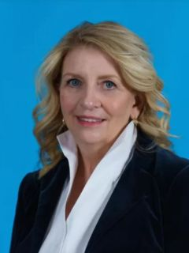
Catherine Russell is the eighth Executive Director of the United Nations Children’s Fund (UNICEF), leading the organization’s work for children across more than 190 countries and territories. She brings decades of public service experience focused on advancing the rights of underserved communities and developing high-impact policies and programmes for women, girls, and children, including in humanitarian settings. Appointed by the Secretary-General of the United Nations, she assumed her role on 1 February 2022.
From 2020 to 2022, Ms. Russell served as Assistant to the President and Director of the White House Office of Presidential Personnel under President Joe Biden. She previously served as the U.S. Ambassador-at-Large for Global Women’s Issues at the Department of State (2013–2017), where she integrated women’s rights across U.S. foreign policy, represented the United States in more than 45 countries, and was the principal architect of the landmark U.S. Global Strategy to Empower Adolescent Girls.
Her earlier roles include serving as Deputy Assistant to President Barack Obama, Senior Advisor on International Women’s Issues for the Senate Foreign Relations Committee and Associate Deputy Attorney General at the Department of Justice. She has also taught at the Harvard Kennedy School and served on multiple boards dedicated to women’s rights and global development.
Ms. Russell holds a Bachelor of Arts in Philosophy from Boston College and a Juris Doctor degree from the George Washington University Law School.

Ms. Diene Keita
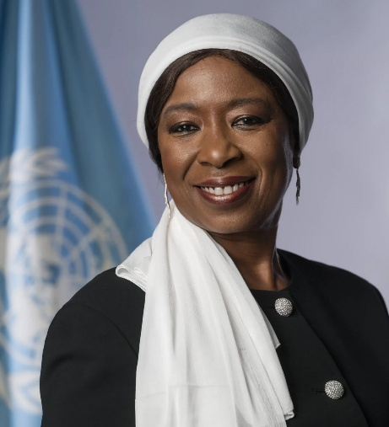
Diene Keita is the United Nations Under-Secretary-General and Executive Director of the United Nations Population Fund (UNFPA). Appointed by the UN Secretary-General on 29 August 2025, she
leads UNFPA’s global work to advance sexual and reproductive health and rights, promote gender equality, and strengthen demographic resilience. She previously served as Acting Executive Director and as Deputy Executive Director Programme since August 2020.
Ms. Keita brings more than three decades of experience in international development, diplomacy, and public service. She served as Guinea’s Minister for Cooperation and African Integration before taking on senior leadership roles across UNFPA and the United Nations Development Programme (UNDP). She has served as UNFPA Representative in Nigeria and the Democratic Republic of the Congo, and as United Nations Resident Coordinator in Mauritania, Benin and the Democratic Republic of the Congo. She began her United Nations career in 1990 with UNDP.
Her work has focused on women’s and youth empowerment, inclusive growth, demographic issues, and sustainable human development, with a strong emphasis on sexual and reproductive health and ending gender-based violence, including in humanitarian settings.
Ms. Keita holds a doctorate in Law and advanced degrees from the University of Paris 1 Panthéon-Sorbonne.

Ms. Pernille Fenger
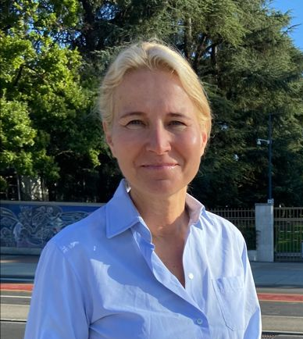
Pernille Fenger is the Chief of the UNFPA Representation Office in Geneva, a role she assumed on 1 August 2023. From 2009 to 2023, she served as Director of UNFPA’s Nordic Representation Office in Copenhagen, where she strengthened political support, resource mobilization, and strategic partnerships across the Nordic region.
With more than 33 years of experience in international development, Ms. Fenger has dedicated her career to advancing sexual and reproductive health and rights, gender equality, and climate and environmental issues. Through her work in advocacy, programme management, and strategic communications, she has helped shape global policy on health and gender and strengthened partnerships in support of mandate of the United Nations Population Fund and human-rights-based approaches to development.
Before joining UNFPA, she worked at the Danish Ministry of Foreign Affairs in the Asia and multilateral departments, focusing on development cooperation and international policy.
Ms. Fenger holds a master’s degree in history from the University of Copenhagen and a French language diploma from the Sorbonne.

Dr. Pascale Allotey
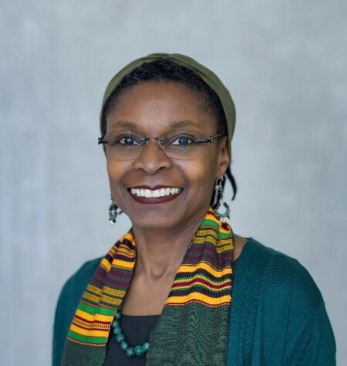
Dr. Pascale Allotey is the Director of the Department of Sexual, Reproductive, Maternal, Child and Adolescent Health and Ageing at the World Health Organization, and oversees HRP, the UNDP-UNFPA-UNICEF-WHO-World Bank Special Programme of Research, Development and Research Training in Human Reproduction. She is an internationally recognized leader in gender equity, sexual and reproductive health and rights, and human rights in global health, with more than 30 years of experience across clinical practice, implementation research, health systems, and community engagement.
Before joining WHO, Dr. Allotey served as Director of the United Nations University International Institute for Global Health (UNU-IIGH), where she led institutional efforts to embed gender and intersectionality in health governance. Her interdisciplinary expertise spans anthropology, epidemiology, and health policy, and she has published extensively on gender, health inequities, harmful practices, migrant health, and rights-based approaches to sexual and reproductive health and rights.
Dr. Allotey holds a PhD in Public Health and a Master of Medical Science in Community Health from the University of Western Australia, and a B.A. in Nursing and Psychology from the University of Ghana.

Ms. Irene Kaggwa
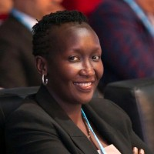
Ms. Irene Kaggwa is the Programme Manager at the International Telecommunication Union (ITU) for Giga, the joint ITU–UNICEF initiative working to connect every school to the Internet by 2030. She brings more than two decades of experience in communications and information and communications technology (ICT) regulation, digital policy and technology-enabled socio-economic development.
Before joining ITU, Ms. Kaggwa spent over 23 years at the Uganda Communications Commission, the national regulator for the communications sector. During her tenure, she held several senior leadership roles, including serving as Acting Executive Director from 2020 to 2023. Her work covered policy development, strategic planning, research, cybersecurity, and the implementation of ICT initiatives aimed at expanding digital inclusion and supporting national development priorities. She is widely recognized for her leadership in advancing ICT access, digital transformation, and the use of technology to support inclusive development.
Ms. Kaggwa holds a Master of Science in Communications Systems and Signal Processing from the University of Bristol and a Master of Science in Economic Management and Policy from the University of Strathclyde in the United Kingdom of Great Britain and Northern Ireland.

