62nd session of the Human Rights Council
Annual panel discussion on the adverse impacts of climate change on human rights
Theme: Facilitating actionable pathways for gaining momentum in climate financing in the context of addressing the adverse impacts of climate change on the full realization of human rights for all people
19 June 2026

BIOGRAPHIES OF SPEAKER AND PANELLISTS

OPENING STATEMENT

Mr. Volker Türk
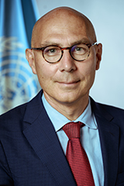
Mr. Türk is the current United Nations High Commissioner for Human Rights. He took up his official functions as High Commissioner on 17 October 2022.
He has devoted his long and distinguished career to advancing universal human rights, notably the international protection of some of the world's most vulnerable people - refugees and stateless persons.
Prior to this, Mr. Türk was the Under-Secretary-General for Policy in the Executive Office of the United Nations Secretary-General where he coordinated global policy work. He also ensured United Nations system-wide coordination in the follow-up to the Secretary-General’s “Call to Action for Human Rights” and his report, Our Common Agenda, which sets out a vision to tackle the world’s interconnected challenges on foundations of trust, solidarity and human rights. He previously served as Assistant Secretary-General for Strategic Coordination in the Executive Office of the Secretary-General (2019-2021).
As Assistant High Commissioner for Protection in the Office of the United Nations High Commissioner for Refugees (UNHCR) in Geneva (2015-2019), Mr. Türk played a key role in the development of the landmark Global Compact on Refugees.
Over the course of his career, he held a number of key positions including at UNHCR headquarters where he served as Director of the Division of International Protection (2009-2015); Director of Organizational Development and Management (2008-2009); and Chief of Section, Protection Policy and Legal Advice (2000-2004). Mr. Türk also served UNHCR around the world, including as Representative in Malaysia; Assistant Chief of Mission in Kosovo and in Bosnia and Herzegovina, respectively; Regional Protection Coordinator in the Democratic Republic of the Congo; and in Kuwait.
Mr. Türk holds a doctorate in international law from the University of Vienna and a Master of Laws degree from the University of Linz, Austria. He has published widely on international refugee law and international human rights law. He is fluent in English and French and has a working knowledge of Spanish.
***

PANELLISTS

H.E. Ms. Patricia Ann Hermanns
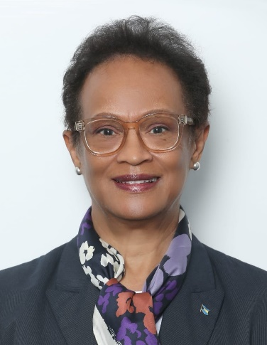
Patricia Hermanns currently serves as Ambassador and Permanent Representative of The Bahamas to the United Nations in Geneva Switzerland, a position she has held since May 2022. Since her appointment she has been nominated to serve on numerous international bodies and committees and has chaired numerous high-level meetings including the Human Rights Council Forum on Democracy and the Rule of Law. In 2025, Ambassador Hermanns was selected by the President of the Human Rights Council to serve on the Gender Advisory Board of the Council. She was also elected by the Group of Latin American and Caribbean States (GRULAC) to represent the region as chair of the Meeting of UNCAT States Parties and elections of Members of the Committee Against Torture, becoming the first Caribbean representative to do so. In 2024, Ambassador Hermanns was unanimously nominated to represent the Group of Latin America and Caribbean States (GRULAC) as a member of the Consultative Group of the Human Rights Council and to serve on the Ad Hoc Committee for the selection of Deputy Director-General of the International Organization for Migration. She has also served as Chair of the Caucus of Ambassadors of Caribbean Community (CARICOM) Member States in Geneva as well as coordinator of GRULAC Ambassadors for the International Organization for Migration and for the United Nations Office at Geneva. Ambassador Hermanns currently serves as the focal point Ambassador for the CARICOM on human rights matters and is a core State Ambassador of the Convention Against Torture Initiative. Ambassador Hermanns has served on high-level Ministerial delegations including to the 2022 Plenipotentiary Conference of the International Telecommunications Union (ITU) in Bucharest, Romania and the 2025 Fourth International Conference on Financing for Development held in Sevilla, Spain. She has participated as a high-level panellist and invited speaker at numerous formal dialogues on topics including human rights, sustainable development, climate change, international cooperation in tax matters, sovereign debt and the reform of the international financial architecture, financing for development, gender equality and the rights of persons with disabilities.
Prior to assuming her current position, Ambassador Hermanns held senior management positions in domestic and international banking institutions as well as in the life and health insurance sector in The Bahamas becoming the first woman to lead two publicly traded Insurance companies consecutively. She also served as CEO of the National Insurance Board of The Bahamas.
In other areas of her career, she has served as the first deputy chair of the Bahamas International Securities Exchange and deputy chair of the Securities Commission as well as director of Bahamas Power and Light and Bank of The Bahamas.
Ambassador Hermanns is fluent in English and Spanish and has working knowledge of French.

Mr. Stanley Kimaren Riamit
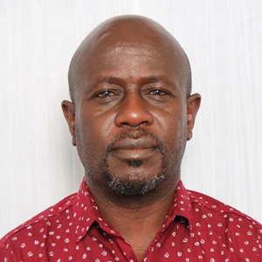
Kimaren Riamit is an Indigenous Peoples’ leader from the Pastoralists Maasai Community in southern Kenya. His is the Founder-Director of Indigenous Livelihoods Enhancement Partners (ILEPA) a non-for-profit community based Indigenous Peoples organization advocating for Indigenous Peoples’ right to self-determination across scales.
Kimaren has extensive exposure and experience in engaging with and influencing international processes and mechanism of interests to Indigenous Peoples in the context of human rights, ways of knowing and doing, biodiversity conservation and climate change, in which he has represented the global Indigenous Peoples’ movement in various capacities, such as serving as observer to the World Bank climate change related processes and currently at the Indigenous Peoples Advisory Group (IPAG) of the Green Climate Fund (GCF) representing Africa.
He has been deeply engaged in national and sub-national efforts towards domestication and operationalization of international and national level policy commitments and decisions of interest to and with a bearing on Indigenous Peoples’ rights. Kimaren Riamit has vast fast-hand experience facilitating on-the-ground implementation of Indigenous Peoples self-determined sustainable development initiatives inspired by indigenous ways of knowing and doing.
Kimaren is a holder of a Master of Arts degree in Development Anthropology, a Post Graduate Diploma in Project Planning and Management, and a BSc. degree in Foods, Nutrition and Dietetics. He has served as a researcher for ILEPA, other local and international organizations including UN Agencies and the World Bank, and as field instructor/lecturer for international field study programs undertaken in East Africa by two international Universities (McGill and Utrecht Universities).
Kimaren is interested in the Anthropology of Development, human rights and indigenous ways of knowing and doing, with a particular focus on Indigenous Peoples’ rights, and governance. Specifically, how property rights to land and natural resources, pastoralism, conservation and climate change, decision-making arrangements interact to promote or impede rights to self-determination of Indigenous Peoples.

Ms. Maria Ron Balsera
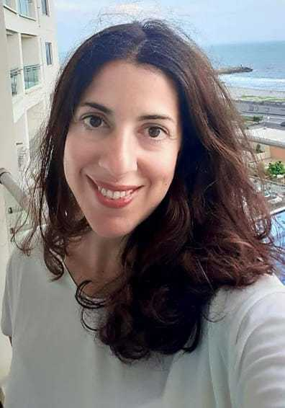
Dr. Maria Ron Balsera is the Executive Director of the Center for Economic and Social Rights (CESR). A feminist leader with over 20 years of experience in human rights and economic justice, she has built and led collaborative research, advocacy, and campaigning initiatives with national, regional, and international coalitions across Africa, Asia, and Latin America.
Her work has focused on the right to education, public service financing, and tax justice. Before joining CESR, Maria served as Policy Advisor on Fiscal Justice at ActionAid International and coordinated the Tax and Education Alliance. She has extensive experience managing multi-country programmes and transnational partnerships involving NGOs, social movements, and trade unions, and has led research and advocacy efforts in numerous countries.
Maria has also lectured at several universities, including the University of Roehampton and Bielefeld University, and previously worked with the Right to Education Project and Human Rights Watch. She has authored influential publications and undertaken consultancy work for a range of international organisations.
She holds a PhD in Education from Bielefeld University, completed through a Marie Curie Fellowship, as well as an MSc in Human Rights from the London School of Economics and an LL.M. in Human Rights from Universidad Carlos III de Madrid. She has conducted research at UCL’s Institute of Education and at UC Berkeley through a research exchange programme.

Mr. Mohammad Hafijul Islam Khan
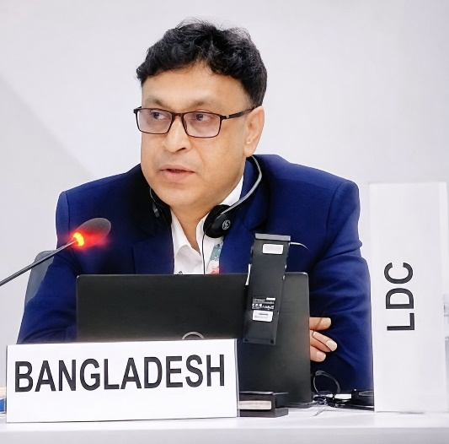
Adv. M. Hafijul Islam Khan, LLM (University of Dhaka), LLM (Central European University), is an environmental lawyer affiliated with the Supreme Court of Bangladesh and a climate change negotiator with Bangladesh Delegation. He is the founder and Director of the Centre for Climate Justice-Bangladesh (CCJ-B).
He is one of the lead climate negotiators for 44 Least Developing Countries (LDCs) group at UNFCCC and acting as coordinator for Loss and Damage Team of LDCs. He served as the Co-chair of the Executive Committee of Warsaw International Mechanism for loss and damage at UNFCCC. Currently he is serving as Alt. Member of the Paris Agreement Implementation and Compliance Committee. Mr. Khan is an advisor to the LDCs Member to the Board of the Fund for Responding Loss and Damage at UNFCCC.
He worked with New York University Law School, USA as a research fellow and taught Environmental Law in North South University in Bangladesh.

