Human Rights Council
Annual full-day meeting on the rights of the child
Theme: Rights of the child and violations of the human rights of children in armed conflicts
Assembly Hall, Palais des Nations, 9 March 2026
Panel 1: 10:30-12:30, Panel 2: 14:30-16:30
Biographies of panellists

Morning panel – 10:30 to 12:30
Topic 1: Mainstreaming the rights of children in armed conflict: prevention & protection

Ms. Nada Al-Nashif, United Nations Deputy High Commissioner for Human Rights
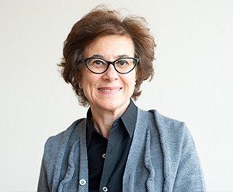
Ms. Nada Al-Nashif was appointed United Nations Deputy High Commissioner for Human Rights on 6 December 2019, assuming the position on 10 February 2020.
She brings to the role close to 30 years of experience within the United Nations system around the world. As an economist and development practitioner, Ms. Al-Nashif has taken on increasingly complex management roles during her career within the United Nations, including leading strategic organisational transformation processes.
From 2015-2020, Ms. Al-Nashif served as Assistant Director-General for Social and Human Sciences at UNESCO in Paris, leading a portfolio that targets the mobilisation of knowledge for inclusive, just and sustainable societies.
Prior to joining UNESCO, she served as Assistant Director-General/Regional Director of the International Labour Organization's Regional Office for Arab States, based in Beirut, Lebanon (2007–2014). She previously worked at the United Nations Development Programme (UNDP), where she started her United Nations career in 1991, serving in Libya (1992-1995), Lebanon (2000-2004), Iraq (2003) and at Headquarters in New York (1995- 2000, 2005-2006).
She holds a Bachelor of Arts in Philosophy, Politics and Economics (1987) from Balliol, Oxford University (UK) and a Master's in Public Policy (1991) from the Kennedy School of Government, Harvard University (USA).

Yansel, 15 years, child rights advocate from Colombia (video statement)
[No photo provided due to safeguarding considerations]
Yansel is a 15-year-old adolescent from Colombia. She has been part of the National Participation Network, supported by Save the Children, for four years, and she is also a member of her municipality’s participation board. In these spaces, she shares experiences with other children from across the country and learns about her rights, caring for the environment and how to contribute to her community. She enjoys participating because she values being able to express herself, listen to other children and build ideas collectively. The changes she wants to see in the world: “That no child has to grow up in the midst of conflict, that we have more opportunities and that our families are more united.

Ms. Vanessa Frazier, Special Representative of the Secretary-General for Children and Armed Conflict

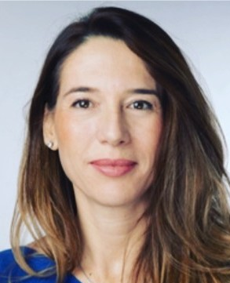
Ms. Vanessa Frazier of Malta was appointed Special Representative for Children and Armed Conflict in October 2025, succeeding Virginia Gamba of Argentina who had served in the role since 2017.
Ms. Frazier brings over three decades of diplomatic experience and a strong commitment to child protection. From 2020 to 2025, she served as the Permanent Representative of Malta to the United Nations in New York, where she played a key role in multilateral negotiations and consensus building. She chaired the Security Council Working Group on Children and Armed Conflict, presided over the Council twice (February 2023 and April 2024) and acted as Facilitator for the Iran nuclear agreement (JCPOA) and Chair of the 1267 Sanctions Committee on Al Qaeda/Daesh. Her leadership advanced human rights and humanitarian language in critical resolutions.
Ms. Frazier also served as Vice-President of the 74th session of the General Assembly and chaired the Second Committee (Economic and Financial), leading the first all-women bureau in United Nations history. Earlier in her career, she held senior positions including Ambassador to Italy (2013–2019), Acting Permanent Secretary at Malta’s Foreign Ministry, Ambassador for Migration and Ambassador to Belgium.
She holds a Doctorate Honoris Causa from Luther College (USA) and a Master’s in Diplomatic Studies with a focus on International Law from the University of Malta. Fluent in Maltese, English and Italian, Ms. Frazier is recognized for her ability to navigate complex global negotiations and advocate for the protection of children affected by conflict.

Mr. Benoit Van Keirsbilck, Member of the Committee on the Rights of the Child

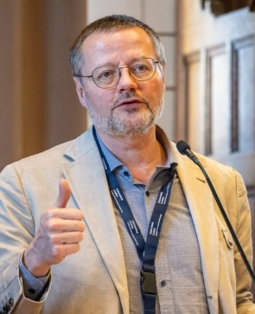
Mr. Benoît Van Keirsbilck is the Director of the Belgian section of Defence for Children – International (DCI). He is Chief Editor of the Journal of Children’s Law (Belgium) and was a member of the Advisory board for the Global study on children deprived of liberty mandated by the General Assembly of the United Nations. He has been elected as a member of the Committee on the Rights of the Child for two terms (2021-2024 and 2025-2029). Mr. Van Keirsbilck holds degrees in law and criminology and is recognized globally for his expertise in promoting access to justice and safeguarding the rights of children in vulnerable situations.

Ms. Cordula Droege, Chief Legal Officer and Head of the Legal Division at the International Committee of the Red Cross
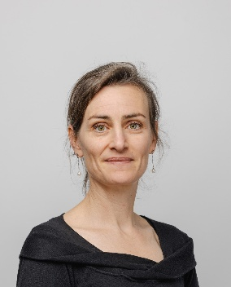
As Chief Legal Officer and Head of the Legal Division, Ms. Cordula Droege leads the ICRC’s efforts to uphold, implement and develop international humanitarian law. She joined the ICRC in 2005 and has held numerous positions in the field and at headquarters, including head of the legal advisers to operations, and chief of staff to the President of the ICRC. She has over twenty years’ experience in the field of international law, having started her career working for the International Commission of Jurists, the Inter-American Court of Human Rights and the Max Planck Institute for International Law. She holds a law degree and a PhD from the University of Heidelberg and an LL.M from the London School of Economics.

Afternoon panel – 14:30 to 16:30
Topic 2: Mainstreaming the rights of children in armed conflict: reintegration and recovery, remedies and reparation

Ms. Nada Al-Nashif, United Nations Deputy High Commissioner for Human Rights

Ms. Nada Al-Nashif was appointed United Nations Deputy High Commissioner for Human Rights on 6 December 2019, assuming the position on 10 February 2020.
She brings to the role close to 30 years of experience within the United Nations system around the world. As an economist and development practitioner, Ms. Al-Nashif has taken on increasingly complex management roles during her career within the United Nations, including leading strategic organisational transformation processes.
From 2015-2020, Ms. Al-Nashif served as Assistant Director-General for Social and Human Sciences at UNESCO in Paris, leading a portfolio that targets the mobilisation of knowledge for inclusive, just and sustainable societies.
Prior to joining UNESCO, she served as Assistant Director-General/Regional Director of the International Labour Organization's Regional Office for Arab States, based in Beirut, Lebanon (2007–2014). She previously worked at the United Nations Development Programme (UNDP), where she started her United Nations career in 1991, serving in Libya (1992-1995), Lebanon (2000-2004), Iraq (2003) and at Headquarters in New York (1995- 2000, 2005-2006).
She holds a Bachelor of Arts in Philosophy, Politics and Economics (1987) from Balliol, Oxford University (UK) and a Master's in Public Policy (1991) from the Kennedy School of Government, Harvard University (USA).

Sara, 16 years, child rights advocate from the Occupied Palestinian Territory (video statement)
[No photo provided due to safeguarding considerations]
Sara is a sixteen-year-old Palestinian refugee girl from a refugee camp in Bethlehem in the West Bank. Her family was forcibly displaced from the village of Deir Rafat during the Palestinian Nakba in 1948. Sara is a committed and ambitious advocate for the rights of children. She has demonstrated strong leadership within her school and community and has increasingly engaged in child-led advocacy spaces to ensure that children’s voices are heard.
Sara was highly motivated to expand her engagement on platforms that amplify children’s lived experiences and demands for protection and justice, especially in the light of the devastating impact of the ongoing aggression on children in Gaza.
Together with her peers, Sara joined QADER’s Child Advocacy Board, a platform through which she actively voices the concerns and priorities of children in the Occupied Palestinian Territory. She aspires to a world grounded in freedom, justice and peace, where children everywhere are protected from war and violence. Through her resilience and determination, Sara has emerged as a powerful young voice carrying the experiences and aspirations of oppressed children to the global stage.

Mr. Robert Doya Nanima, Special Rapporteur on Children in Conflict Situations of the African Committee of Experts on the Rights and Welfare of the Child (video statement)

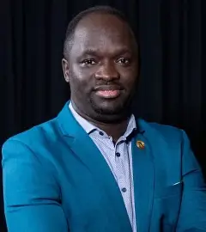
Mr. Robert Doya Nanima is an Associate Professor in the Faculty of Law at the University of the Western Cape. He is also a member of the African Committee of Experts on the Rights and Welfare of the Child (ACERWC), serving as Special Rapporteur on Children Affected by Armed Conflict.
His scholarly work combines criminal justice, human rights and children’s rights. He has published extensively on issues such as child justice, evidence law, the rights of refugee and asylum-seeking children, and the impact of conflict on children’s access to education, justice and welfare.

Ms. Hazel De Wet, Deputy Director of the Office of Emergency Programmes, United Nations Children’s Fund

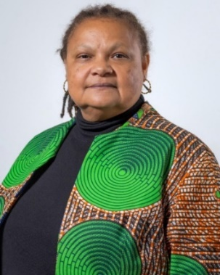
Ms. Hazel De Wet is the Deputy Director of UNICEF’s Office of Emergency Programs in Geneva, where she provides strategic leadership and oversight for global humanitarian response and emergency preparedness. She brings extensive experience in political affairs, human rights, civilian protection, women’s rights, international relations, and multilateral diplomacy within the United Nations system.
Her career reflects a unique blend of grassroots engagement and high-level political work, ranging from direct collaboration with local actors in crisis settings to shaping policy and intergovernmental processes at United Nations Headquarters. Over the past 14 years, she has served on the frontlines of conflict, post-conflict and complex emergency environments, primarily through senior roles in United Nations Peacekeeping Missions in the Sudan and South Sudan. She holds a Law degree in Human Rights from the University of London and a Bachelor’s degree in Political Science from the University of the Western Cape.

Ms. Clara Sandoval, Director of Programmes at the Global Survivors Fund

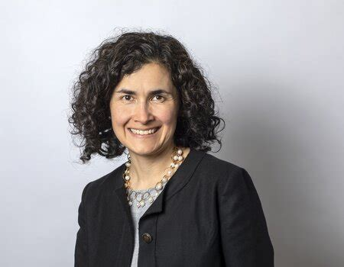
Ms. Clara Sandoval joined the Global Survivors Fund as Director of Programmes in 2021. She is a qualified lawyer and a leading expert on reparations, human rights and transitional justice. Clara is an honorary professor at the University of Essex, a founding member of the Essex Transitional Justice Network and former Director of the Essex Human Rights Centre.
She has extensive experience working on reparations cases before the Inter-American Court of Human Rights and the International Criminal Court (ICC), including as an expert in cases involving conflict-related sexual violence. Her work with survivors has focused on domestic reparation programmes in countries such as Colombia, Ukraine, Peru, Iraq, Guatemala and Chile.

