62nd session of the Human Rights Council
Panel discussion on the intensification of efforts to empower women and girls in and through sport
Tuesday, 23 June 2026, 10 a.m. – 12 p.m.

BIOGRAPHIES OF SPEAKER AND PANELISTS

OPENING STATEMENT

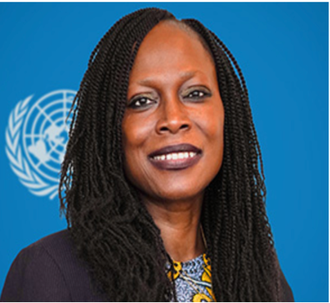
Ms. Awa Dabo
Ms. Awa Dabo is the current United Nations Deputy High Commissioner for Human Rights. She is a human rights lawyer with extensive experience in crisis recovery, peace building, transitional justice, humanitarian affairs and development. Awa has held several positions within the United Nations including as the Director and Deputy Head of the UN’s Peacebuilding and Peace Support Office, in New York. Awa was previously Chief of Country Oversight and Support, UNDP Regional Bureau for Africa, Senior Advisor and Head of the Crisis and Fragility Policy and Engagement team for the Crisis Bureau of UNDP, Country Director for UNDP in Tanzania, and Regional Programme Manager and Team Leader with UNDP’s Bureau for Crisis Prevention and Recovery.
Awa has experience both at HQ and at country offices, having worked on and/or in Africa, Asia, Latin America, the Caribbean, and Europe. Awa has also worked with UNDP’s Crisis Response Unit in New York, as Crisis Coordinator for Africa, Latin America and the Caribbean. With UNDP in Geneva, Awa worked as Transitional Governance Specialist, and subsequently as Reintegration Specialist. With UNDP Liberia, Awa was the Chief Technical Specialist and Programme Manager, Human Rights and Protection Programme. During her professional career, Awa has worked with other UN and non-UN entities including the UN Office for the Coordination of Humanitarian Affairs (OCHA), the Office of the UN High Commissioner for Human Rights (OHCHR), the UN Department for Peacekeeping Operations (UN DPKO, now DPO) and the African Society of International and Comparative law - an international law NGO previously based in London England.
Awa holds an LLM in International Human Rights Law from the University of Nottingham (1996) and a BA in Law, Sociology and Social Anthropology from the University of Keele (1994).
***
PANELLISTS
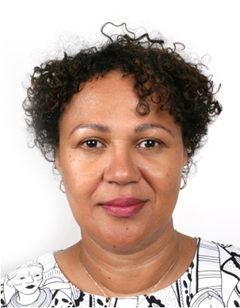
Ms. Vera Lucia Isaac Paquete-Perdigão
Ms. Paquete-Perdigão is the Director of the Labour Governance and Sectoral Policies Department (GOVERNANCE) at the International Labour Organization. Her department provides advice and assistance on a range of topics to advance good governance and the realization of labour rights in the world of work through effective dialogue and inclusive labour institutions.

Ms. Paquete-Perdigão, an economist, has a professional career in development at both national and international levels spanning some 30 years. She has extensive experience covering economic development, child labour, project management, poverty reduction, gender and management.
Ms. Maryam Bint Abdullah Al-Attiyah
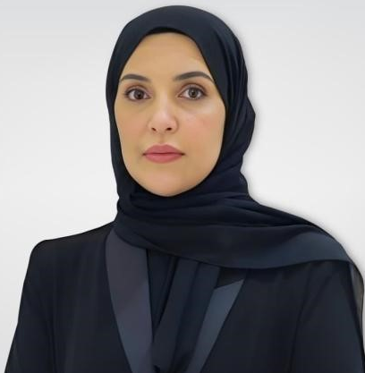
Ms. Maryam bint Abdullah Al-Attiyah is the Chairperson of the National Human Rights Committee of Qatar. She began her professional career at the National Human Rights Committee at the very early stages of its establishment, joining the Committee as a Social Researcher. She subsequently progressed through several leadership positions, including Director of the Relations and Media Unit, and later Director of the Programs and Education Department. Following six years of experience and notable achievements in activating the Committee’s programs, promoting a human rights culture, and raising public awareness, she was appointed Secretary-General of the National Human Rights Committee on 7 October 2009. In 2011, she received the Women Achiever Excellence Award during the Regional Women Leaders Forum in Dubai, in recognition of her pioneering role in women’s empowerment and leadership of human rights institutions. In 2013, she was awarded Best Female Leadership Personality in the Middle East by the Middle East Excellence Award Institute (Dubai), in recognition of her achievements in the field of human rights and institutional leadership. In light of her continued accomplishments and executive oversight of the Committee’s work, she was selected as a member of the National Human Rights Committee in 2015. On 27 October 2021, Ms. Maryam bint Abdullah Al-Attiyah was elected Chairperson of the National Human Rights Committee. In 2022, she assumed the Presidency of the Global Alliance of National Human Rights Institutions (GANHRI) for a three-year term. In the same year, she also assumed the presidency of the Arab Network of National Human Rights Institutions. In June 2025, Ms. Maryam bint Abdullah Al-Attiyah was elected as a member of the Independent Permanent Human Rights Commission of the Organization of Islamic Cooperation (OIC).

Ms. Celine van Till
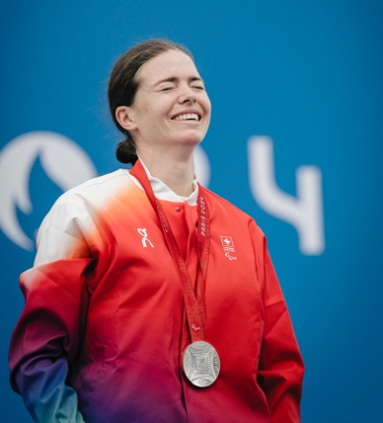
Celine van Till is a Swiss paralympian and world champion in para-cycling. Being a member of the Parliament of Geneva since 2023, she promotes the rights of disabled people and a better inclusion. She had a serious horse-riding accident in 2008 and sufferd from brain injury. After being one month in coma, she overcame many obstacles in order to come back to life. Being disabled, she turned those hard times into strenghts that became stepping stones for her in her personal life and to help other's.
In 2011, she started writing her story and published her book “Step by step” (in French, “Pas à pas”). She then became Miss Handicap Switzerland, played a role model for disabled people and worked towards a better inclusion. At the same time, she went on to further education studies in marketing and management. Later, she studied ethics as well. She is involved in many causes and shares her inspiring experience through conferences. The city of Geneva awarded her with the “Genève Reconnaissante” medal in 2018 for the message of hope, courage and determination which Celine relays every day. The same year, she founded the "Association Tout est Possible" which supports disabled people in sports and competition, believing that diversity and inclusion could be promoted through sports. She also integrated the board of "Handicap International, humanity and inclusion" ten years ago. In 2017, she published a second book "Anything is possible", having written about mindset through her personal experiences (in French, "Tout est possible, dans un sens comme dans l'autre") follwed by a third one "Handicap, an ecveryday's life" (in French "Handicap, une vie de tous les jours") in which she presents other people, accompanied by a colleague. Through her life experience and the numerous challenges faced, she highlights the aspects of a winning mindset and shares her story through conferences. Celine joined the army in 2023, being selected for the sports program thanks to her performanfce in sports. As she wanted to take more challenges, she became the first disabled person with more responsibilities and serves several weeks year.
In sports, she spent ten years competing in the Swiss equestrian national team followed by four years with the Swiss athletic team. She trains relentlessly to be part of the world elite in her class of handicap. Further to a fall while taking part in a sprint and after ending her career in athletics in 2021, she discovered para-cycling. She won two silver medals at the 2024 Paris Paralympic Games and became double word champion in 2025 (time trial and road race).

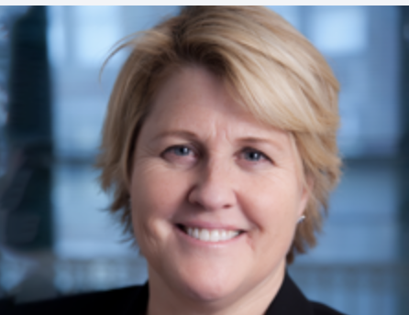
Ms. Mary Harvey
Mary V. Harvey OLY is Centre for Sport and Human Rights Chief Executive. Mary is a seasoned nonprofit leader with over two decades of experience advancing human rights and equality through sport. She joined CSHR in 2019 as its first CEO, leading its transition into an independent organisation, establishing full operational capacity, growing the team, and demonstrating impact. With a long career of leadership in sport governance and sustainability, Mary is recognised for her innovative work in promoting societal change and gender equity through sport, particularly in major international sporting events. As CEO, Mary oversees the development and execution of CSHR’s annual business plan and development plan, ensuring effective revenue generation and financial planning.
Mary spent the first part of her career in the financial services and management consulting sectors before moving into sport administration, holding senior management positions at FIFA and Women’s Professional Soccer. In 2012, Mary launched and led Ripple Effect Consulting, providing management, operational and governance-related guidance to social impact organisations. Prior to joining the Centre, Mary led the development of the human rights strategy for the successful United Bid to bring the 2026 FIFA World Cup to North America.

A lifelong athlete, Mary enjoyed an 8-year career with the US Women’s National Soccer Team, winning the inaugural FIFA Women’s World Cup in 1991 and Olympic Gold in 1996. Her successful career earned her induction into the National Soccer Hall of Fame Class of 2025 and the US Soccer Medal of Honour in 2001. Mary holds an MBA from UCLA Anderson and a BS in Business Administration from UC Berkeley’s Haas School of Business.

