62nd session of the Human Rights Council
Annual full-day discussion on the human rights of women
Panel 2: Commemoration of the International Day of Women in Diplomacy
focusing on women’s right to work and representation in decision-making
24 June 2026, 4-6 p.m.
BIOGRAPHIES OF PANELISTS
OPENING STATEMENTS
Ms. Peggy Hicks
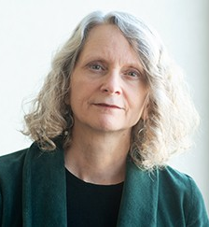
Ms. Peggy Hicks is Director of the Thematic Engagement, Special Procedures and Right to Development Division at the UN Human Rights Office (OHCHR). She provides strategic direction to the office’s work on a broad range of pressing human rights issues, including human rights in the digital age and expanding civic space.
From 2005 to 2015, she was global advocacy director at Human Rights Watch, where she was responsible for coordinating Human Rights Watch's advocacy team and providing guidance to its advocacy worldwide. Ms. Hicks previously served as director of the Office of Returns and Communities in the UN mission in Kosovo and as Deputy High Representative for Human Rights in Bosnia and Herzegovina. She has also worked as the Director of Programs for the International Human Rights Law Group (now Global Rights), clinical professor of human rights and refugee law at the University of Minnesota Law School, and as an expert consultant for the UN High Commissioner for Human Rights.
Ms. Hicks is a graduate of Columbia Law School and the University of Michigan.

Ms. Sofia Calltorp
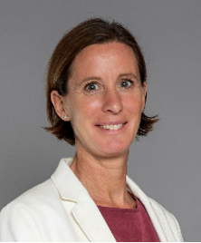
Ms. Sofia Calltorp is the Director of UN Women in Geneva and UN Women’s Chief of Humanitarian Action. In this role, she leads UN Women’s work in Geneva across the organization’s triple mandate as well as its humanitarian section.
Ms. Calltorp has over 25 years of experience working in diplomacy, humanitarian affairs, human rights and development across different regions and organizations. She is a recognized and experienced leader focusing on forging strong partnerships with a multitude of actors to collectively achieve results, and has a strong track record in resource mobilization, international negotiations, strategic communication, and leading and motivating empowered and diverse teams.
Prior to joining UN Women, Ms. Calltorp served as Ambassador and Special Envoy of the Swedish Government for gender issues. She has also served as Sweden’s Ambassador to Zimbabwe where she chaired the International Donor Group, mobilizing and coordinating the international community for a collective response to the multidimensional challenges following the fall of Robert Mugabe.
Ms. Calltorp holds a Master’s degree in International Law and Human Rights from Columbia University and a Master of Science in Political Science from Uppsala University.
PANELISTS
Ms. Chidi King
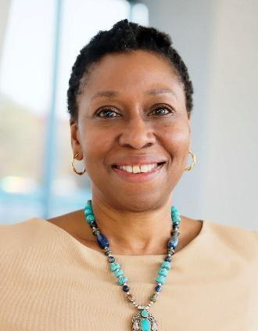
Ms. Chidi King is Chief of the Gender, Equality, Diversity and Inclusion Branch within the Conditions of Work and Equality Department of the International Labour Organization (ILO). In this role, she leads work to eliminate discrimination in the world of work, including discrimination based on gender, race, ethnicity, indigenous status, disability, and HIV status, applying an integrated and intersectional approach.
Prior to joining the ILO, Ms. King served as Director of the Equality Department at the International Trade Union Confederation (ITUC), where she led global trade union work on pay equity, the care economy, gender‑based violence and harassment at work, women’s leadership, and the rights of migrant workers. She has also held roles as Equality and Rights Officer at Public Services International and Employment Rights Officer at the UK Trade Union Congress.
A lawyer by background, Ms. King has more than 20 years of experience providing legal and policy advice on equality and non‑discrimination across public, private, and not‑for‑profit sectors.

Ms. Wafa Asri
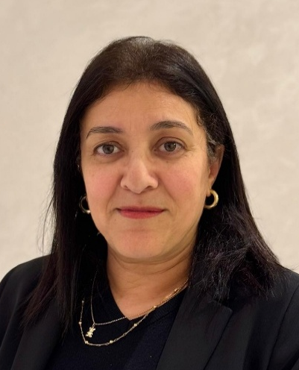
Ms. Wafa Asri is Secretary General for Vocational Training at the Ministry of Economic Inclusion, Small Business, Employment and Skills of Morocco. She has more than 30 years of experience in vocational training, employment, and human capital development, with expertise in the design, management, and evaluation of public policies at national level and in international cooperation contexts.
Throughout her career, Ms. Asri has made a significant contribution to the promotion of productive employment and decent work, improved employability, and stronger alignment between training systems and labour-market needs, in support of inclusive and sustainable growth. She has also contributed to reform processes aimed at aligning national policies with international labour standards, particularly those relating to fundamental rights, social dialogue, and equal opportunities in access to employment.
Ms. Asri holds an engineering degree from the École Nationale Supérieure des Mines de Rabat and a Master’s degree in Training Engineering and Employment Systems from Université Toulouse 1 Capitole.

H.E. Ms. Caroline Ziadeh
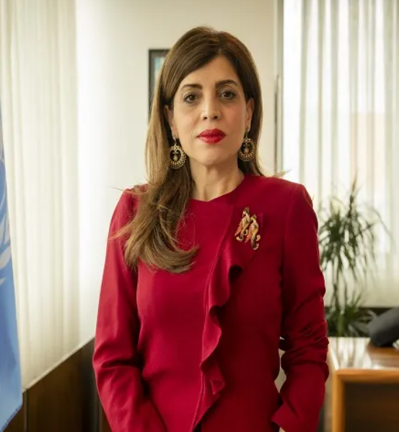
Ms. Caroline Ziadeh is the Permanent Representative of Lebanon to the United Nations Office at Geneva. Prior to her appointment, she served as Special Representative of the Secretary‑General and Head of Mission of the United Nations Mission in Kosovo (2021–2025). She has held multiple senior diplomatic positions throughout her career, including as Ambassador and Director at the Ministry of Foreign Affairs of Lebanon (2017-2021) and as Ambassador and Deputy Permanent Representative of Lebanon to the United Nations (2006-2017).
Ms. Ziadeh’s diplomatic experience spans bilateral and multilateral postings in Europe and at the United Nations, including service as Deputy Head of Mission in London and Austria, Deputy Director of Protocol at the Ministry of Foreign Affairs, and First Secretary of Lebanon in Belgium and to the European Union.
Ms. Ziadeh holds a Master’s degree in Economic and Political Sciences from the Lebanese University and Diplomas in International Relations from the Diplomatic Academy of Vienna and the Université Libre de Bruxelles.

