
Human Rights Council e-deleGATE
Guidelines for co-sponsors:
How to co-sponsor a draft resolution

1) Go to https://e-delegate.un.org and log in to e-deleGATE, Secure Portal for Delegates with your credentials
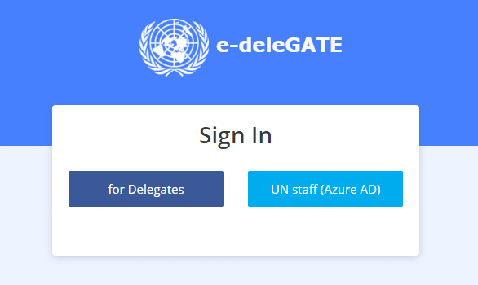
2) Go to General Assembly → Subsidiary Bodies → Human Rights Council →
Human Rights Council e-Sponsorship
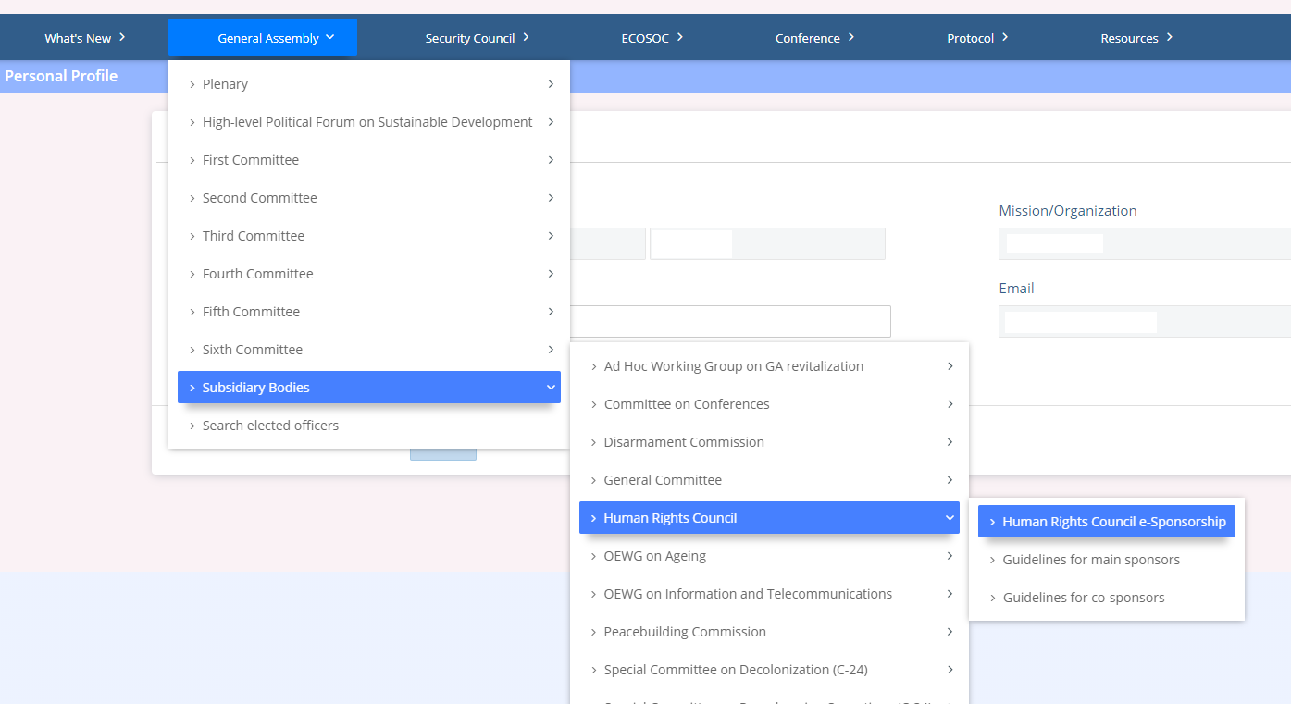
3) Consult the list of draft resolutions and confirm that the one you would like to co-sponsor is marked as -OPEN- for sponsorship:
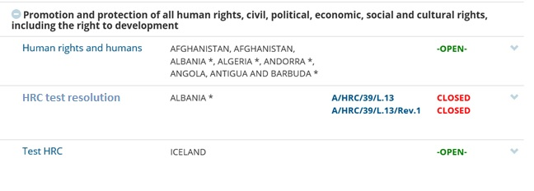
4) Click on the title of the resolution you would like to co-sponsor. You will be able to see all the details, including information on other co-sponsors. Click on the Co-sponsor button:
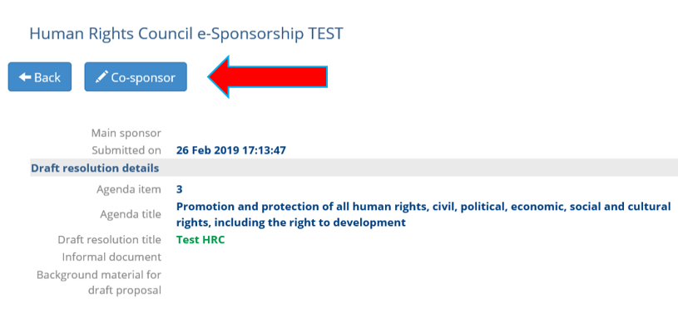

5) Click the checkbox to certify that you are duly authorized to co-sponsor this resolution on behalf of your delegation. Click the Submit button to co-sponsor the draft resolution:
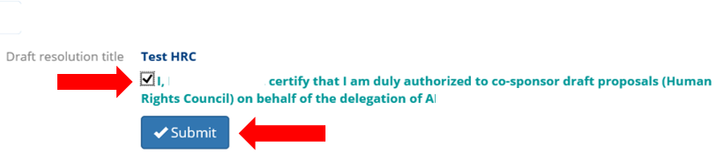
6) When you click on the draft resolution again, you can now see that your co-sponsorship has been registered in the system:
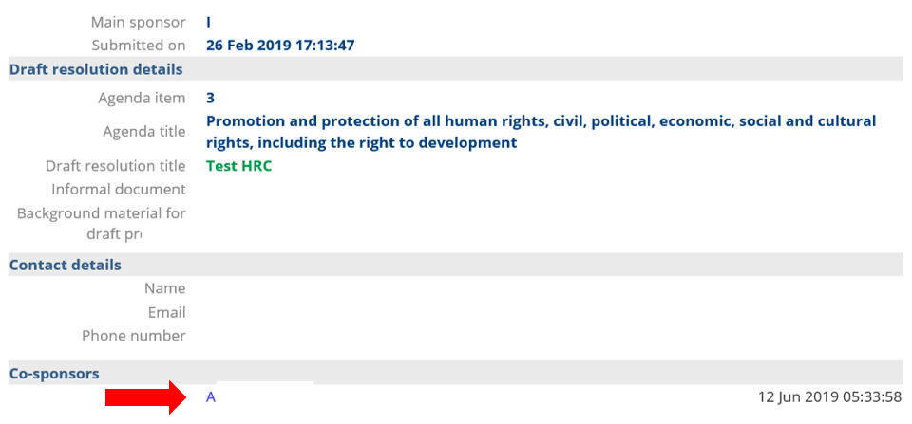

7) An additional way to confirm your co-sponsorship is to click on My Sponsorships. In this view you will be able to see all the resolutions that your delegation has co-sponsored.
