
Human Rights Council e-deleGATE
GUIDELINES FOR MAIN SPONSORS:
INITIATING A DRAFT RESOLUTION FOR SPONSORSHIP
1) Go to https://e-delegate.un.org and log in to e-deleGATE, Secure Portal for Delegates with your credentials
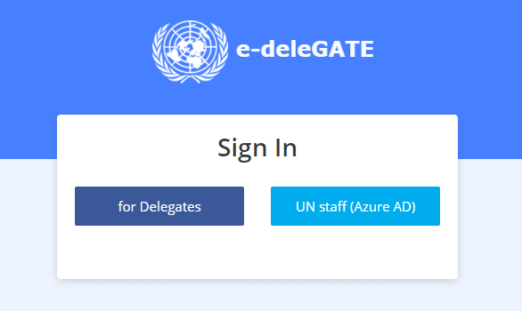
2) Go to General Assembly → Subsidiary Bodies → Human Rights Council →
Human Rights Council e-Sponsorship
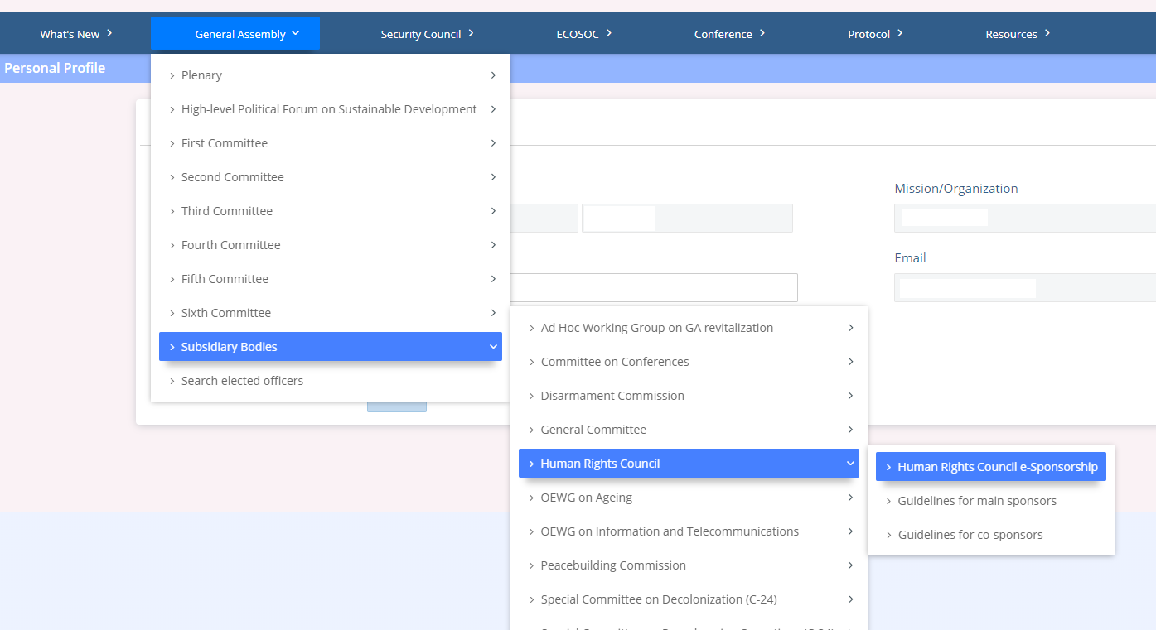

3) Click on Initiate draft resolution:
4) Click on Agenda and select, from the drop-down menu, the agenda item under which you wish to table your resolution:
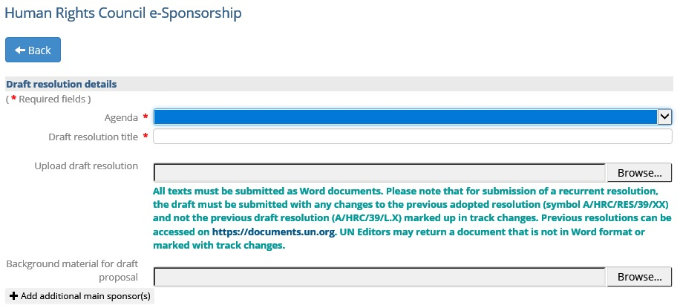

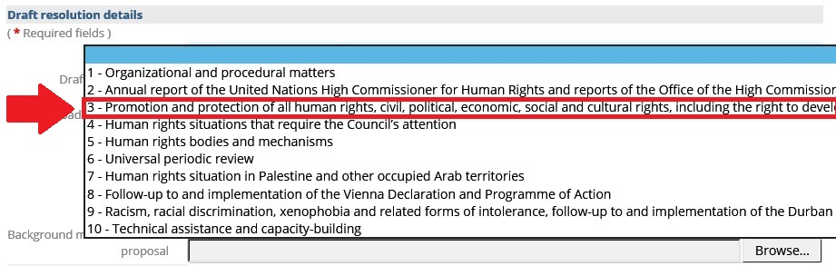

5) Type the title of the resolution in the field for Draft resolution title.
6) In the next field, click Browse to select the file of the draft resolution you wish to upload and click Open. Please make sure that the file name is not too long, otherwise at the end of the process you will get an error message and will not be able to upload the file.
You can use the next field Background material for draft proposal to upload one background document that you may consider useful, for example a previous Council resolution or a resolution of another body that your text draws upon.
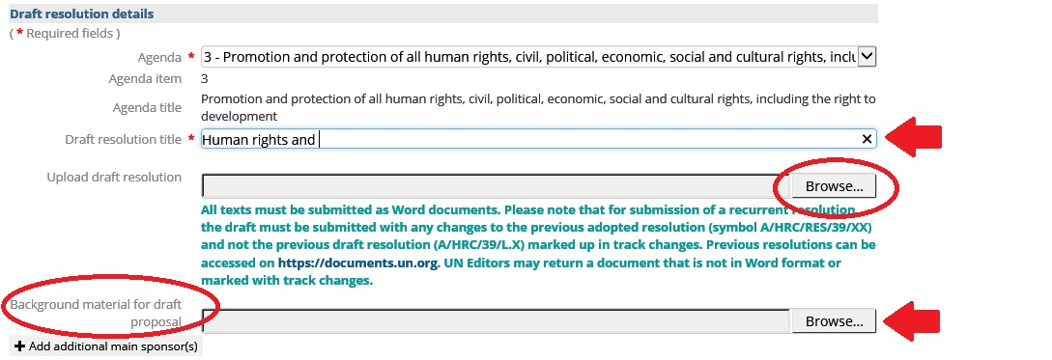

7) Once the draft resolution and optional background documents have been uploaded, you can select other main sponsors (in case of a core group of several main sponsors). To avoid your country from appearing twice in the main sponsors list, please DO NOT select your own country from the list, since by default your country is already among the main sponsors and this list is only for other additional main sponsors.
If the draft resolution is to be submitted on behalf of a group, in the field Sponsorship options, you select can the relevant group from the drop-down menu next to (optional) On behalf of the States Members of the United Nations that are members of. This should be done only by the States designated as coordinators of the respective groups and authorized to table draft resolutions on behalf of those groups. Please click the checkbox to confirm that you are duly authorized to submit draft proposals on behalf of the States Members of the United Nations that are members of the group.
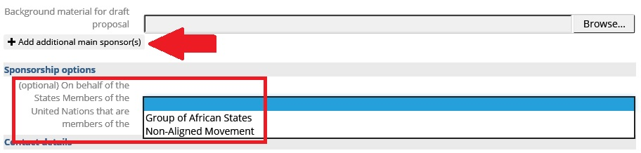
8) Finally, you will need to provide your contact details. You may also add the details of another focal point for this draft resolution, if considered useful. Once you verify all these details, you have to click to certify that you are authorized to submit the draft resolution on behalf of your delegation. You can now click Submit.
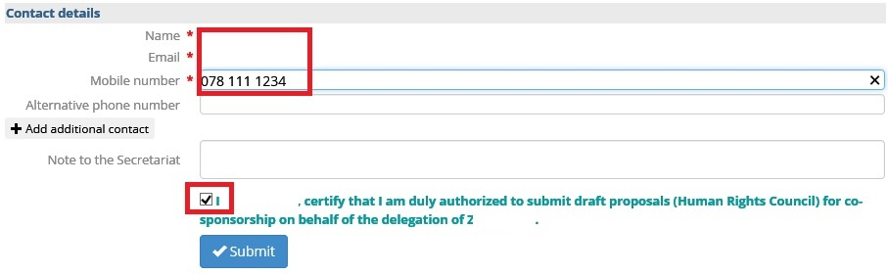
- Congratulations! Your draft resolution is now uploaded under the specific agenda item and is registered in the system as OPEN for co-sponsorship. This means that other delegations can see it, look at your draft and optional background documents you may have provided, and join you as co-sponsors. They will also be able to contact you for additional information or clarification, if necessary.
Whenever you log into the system, you will be able to track progress with your draft resolution and see all the States that have chosen to co-sponsor it. You will also see the draft resolutions tabled by other delegations under the various agenda items.
- Please see separate guidelines on how to co-sponsor a resolution by another delegation.
***

