GUIDANCE NOTE ON VIDEO STATEMENTS

All video statements should be uploaded or sent at least 2 hours before the meeting during which the debate is scheduled to start.
To ensure that the submitted video statement will have sufficient audio and video quality for interpretation, please follow the recommended practices for recording video statements (point C) and the recommended technical specifications for video statements (point D).
In order to enhance participation of persons with disabilities, delegations are strongly encouraged to include captioning of the video statement (point E), as well as to consider including sign language interpretation.
Please note that by submitting a video statement to the Secretariat for the purpose of screening it during an official meeting of the Council, the video statement will become an official record of the Council and will be considered an UN audio-visual asset that can be re-disseminated to media organizations worldwide on a non-commercial basis, in accordance with guidelines of the Department of Global Communications, and will be included in the webcast archive of the meeting on UN Web TV.
In relation to the use of visual materials, it is the long-standing practice of the Council that any speaker intending to display visual materials or images should refer the matter to the Bureau for its consideration and approval at least two working days in advance. Scenography of statements delivered through pre-recorded videos should be neutral and show only official images or symbols. Moreover, the display of images that are provocative, that are related to bilateral disputes or that include commercial logos or brands should be avoided.

Contents
A. How to upload your video statement on Events 2
B. How to send your video statement if uploading is impossible 3
C. Recommended practices for recording video statements 4
D. Recommended technical specifications for video statements 5
E. How to add captions using YouTube 6

HOW TO UPLOAD YOUR VIDEO STATEMENT ON EVENTS
The video statements should be uploaded at least 2 hours before the meeting during which the debate is scheduled to start. The video must be within the speaking time limit for the respective debate. The system will automatically block videos which are even 0.1 sec longer.
Video statements should be uploaded through the online registration system at https://events.ohchr.org/.
After selecting “By video messages”, the delegate will have to enter the name of the speaker and upload the following files:
- The transcript of the statement;
- The video file;
- The subtitles, if any.
Please note that there is no need to upload the speaker’s passport and authorization letter as long as this information has been submitted during accreditation in Indico.
If necessary, it is possible to replace the uploaded video statement by deleting the video and uploading the new one. The order of inscription will not be affected.
After registration, it is still possible to switch between video statement or in person attendance by clicking on “Edit”, and then “Save” – as per the picture below.

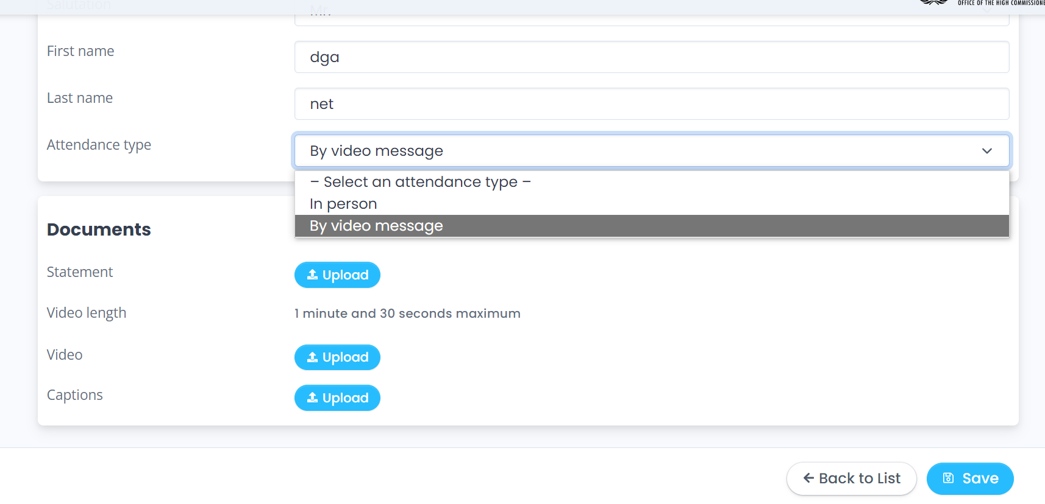

HOW TO SEND YOUR VIDEO STATEMENT IF UPLOADING IS IMPOSSIBLE
- Open a browser on the computer where the files you want to send are located. Go to https://wetransfer.com/.
- Click on “Add your files” and select the following files:
  - Your video message (see below for specifications);
  - A transcript of your statement in Word or accessible PDF formats to facilitate interpretation.
- On the “Email to” field, add:
  - For Member States, observer States and international organizations: ohchr-hrclistofspeakers@un.org
  - For NGOs: ohchr-hrcngo@un.org
- On the “Your email” field, add your own email.
- On the “Message field”, include:
  - The State or NGO on behalf of which you will be speaking;
  - The debate for which you are sending the video message.
- Click on “Transfer”. You will be prompted to enter a verification code, which will be sent to your email (remember to check the spam folder). Copy the verification code, paste it in the transfer windows and click “Verify”.
- Once the verification code has been entered, your files will be uploaded. This might take a few minutes. After that, your files will be sent to us automatically. You will receive an email confirming that your files were sent successfully. You will also receive a confirmation email once we have downloaded your files.

RECOMMENDED PRACTICES FOR RECORDING VIDEO STATEMENTS
With the objective of offering the best quality interpretation possible, and helping speakers to communicate their message more effectively, the Interpretation Service has identified a set of practices for recording video statements.
NOTE: for the smooth conduct of meetings, special attention should always be given to the audio.

- Device
Video statements should not be recorded using a tablet or smartphone.

- Microphone
- Use high quality unidirectional microphones, separate or attached to a headset, with a USB connection to the computer used for recording the video. Please contact conference services for advice on recommended microphones.

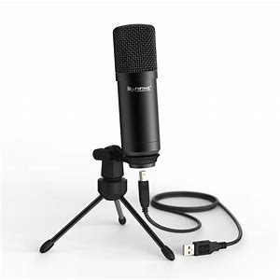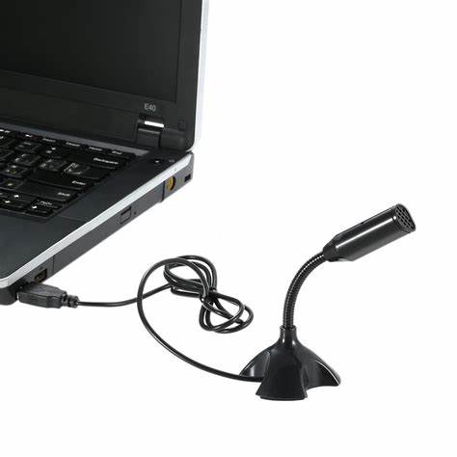
- Do not use the following types of microphone, which do not ensure sufficient sound quality for interpretation:
  - Built-in computer microphone
  - Table top omnidirectional microphones (which capture sound from all directions, including background noise)
  - Wireless earbuds, such as AirPods
- Position or hold the microphone at a reasonable distance (i.e. not too far from the speaker and not so close that breathing is picked up) and speak directly into it. This is especially important if you are using wired earphones with microphone.

- Setting
- Record in a quiet indoor room with the doors and windows closed to avoid reverberation and echoes.
- Background noise and interference should be eliminated (turn off loud air conditioning, etc.).

- Camera and image
- The camera should provide a clear, front-on view of the speaker, ideally from the waist up.
- Avoid strong backlight, such as a window.

- Statement
- Speak at a moderate pace.
- If reading from a statement etc., the text should be provided to the secretariat prior to the video being shown and the interpreters will check against delivery.

RECOMMENDED TECHNICAL SPECIFICATIONS FOR VIDEO STATEMENTS
- MP4
The MP4 or MPEG-4 file format is a digital multimedia container format most commonly used to store video and audio, but it can also be used to store other data such as subtitles and still images.
  - video encoding: H.264

  - audio encoding: Min 44100Hz

  - video resolution: Min 640x480
Max 1920x1080
Frame rate 24, 30 fps

- MOV
MOV is the Apple Inc. Quicktime multimedia container file that contains one or more tracks, each of which stores a particular type of data: audio, video, effects, or text (e.g. for subtitles).
  - video encoding: H.264

  - audio encoding: Min 44100Hz

  - video resolution: Min 640x480
Max 1920x1080
Frame rate 24, 30 fps

- AVI/WMV
Audio Video Interleaved (AVI) is a multimedia container format introduced by Microsoft that can contain both audio and video data in a file container that allows audio-with-video playback.
Windows Media Video (WMV) is a video compression format for several proprietary codecs developed by Microsoft.
  - video encoding: WMV3 (Windows Media Video 9)

  - audio encoding: Min 44100Hz

  - video resolution: Min 640x480
Max 1920x1080
Frame rate 24, 30 fps

HOW TO ADD CAPTIONS USING YOUTUBE
The purpose of these guidelines is to explain how to use YouTube to caption video messages. We recommend its use as an example of a quick, simple and free solution to increase the accessibility of Council sessions, but stakeholders are encouraged to use any means of their choosing to add subtitles to video messages.
These guidelines only address how to create subtitles when a transcript of the video is available. YouTube also generates automatic captions, but this falls beyond the scope of these guidelines.
- Go to www.youtube.com and log in or sign up using a Google account.
- In the upper-right corner, click on the camera icon 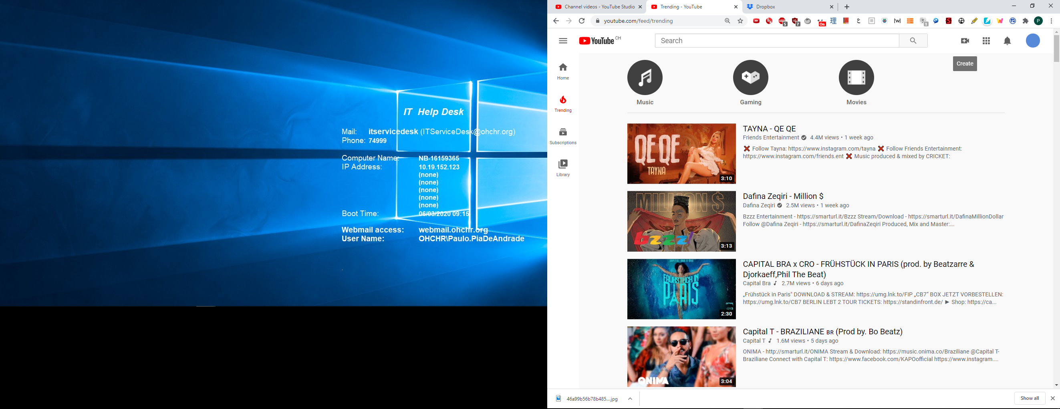 and select “Upload video”.
- Select the video file.
- The following screen appears. As the video will not be made public on YouTube, most details are not relevant. The only required fields are the title and the indication that the video is not meant for children. Complete them and click “Next”.
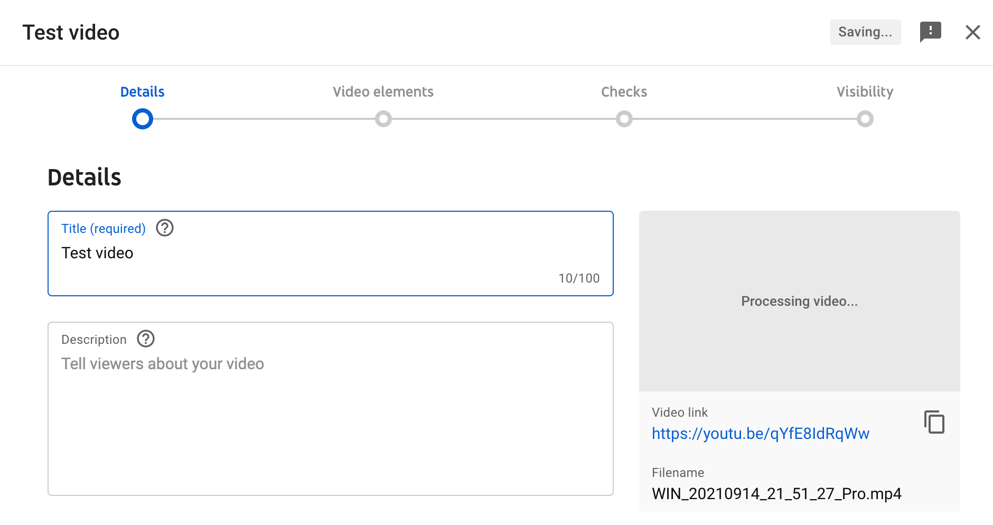

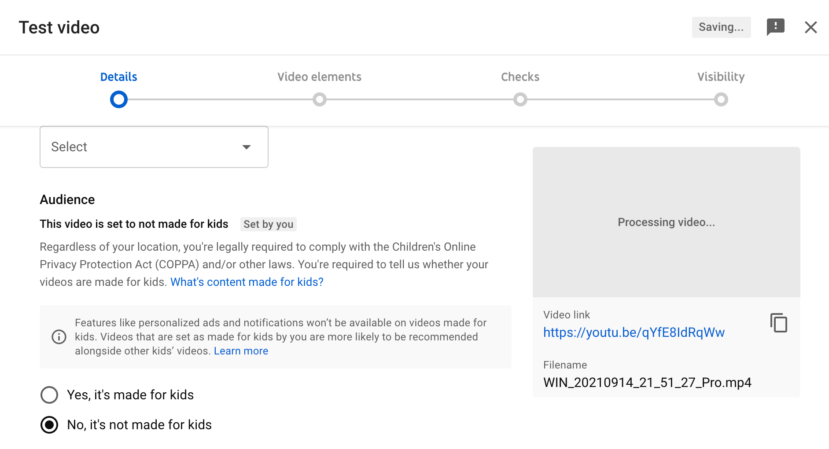

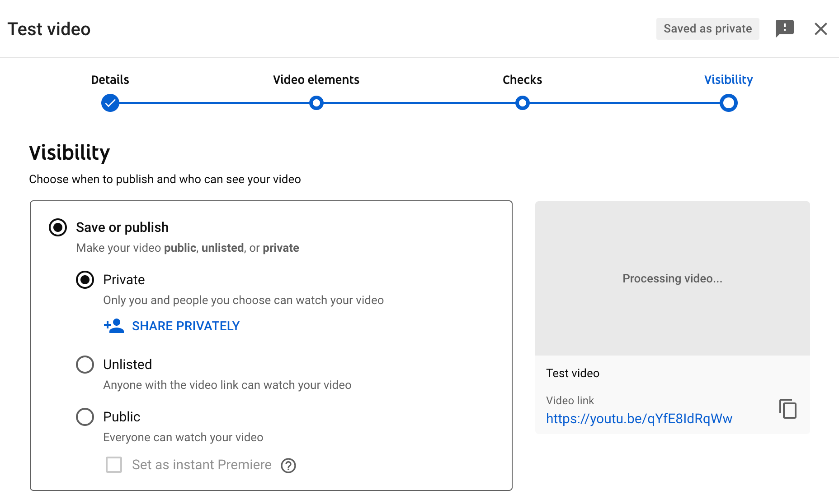
- Click “Next” on the “Video elements” tab. On the “Visibility” tab, select “Private” and click on “Save”.
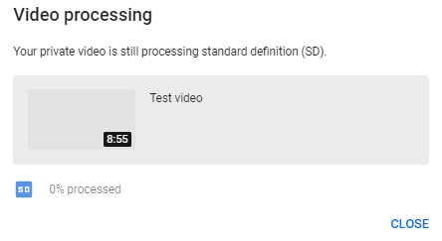
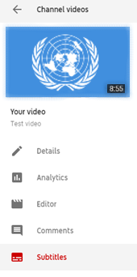
- After the video has finished uploading, it might be necessary to wait some minutes while it is being processed (capture below). Processing time depends on several factors, such as the format and size of the original file, as well as YouTube’s own upload traffic. As a rule of thumb, it can take around one minute of processing for each minute of video – and more than that for higher-resolution video. The progress bar is usually not linear: 0% takes a long time, and from there it jumps to almost completion. A few minutes at 0% does not mean that the processing is frozen.
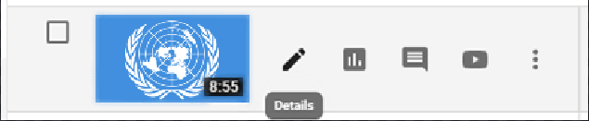
- Go back to the dashboard by clicking on the icon on the upper-left side. On the left-hand column, select . Click on “Details” next to the video to caption.

- After that, select “Subtitles”.
- Select “add” and then “Upload a file”. On the next screen, select “Without timing” for the subtitle file type and press "Continue". The next window will allow you to navigate and upload your file with the transcript.
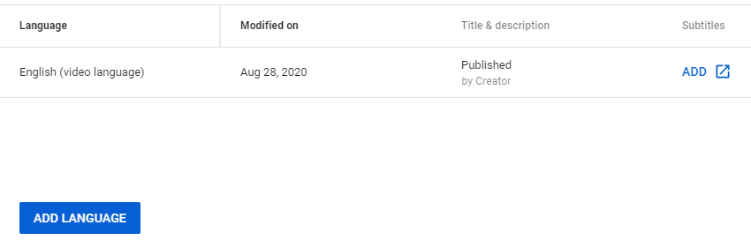

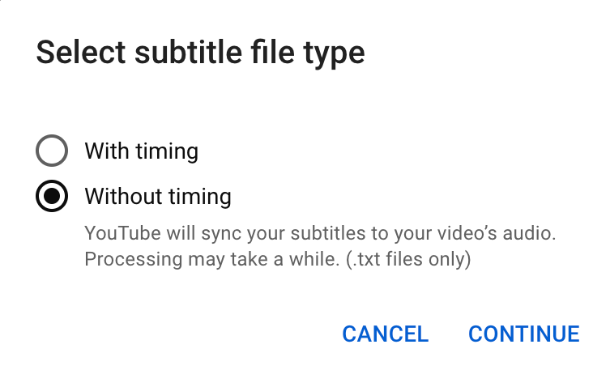
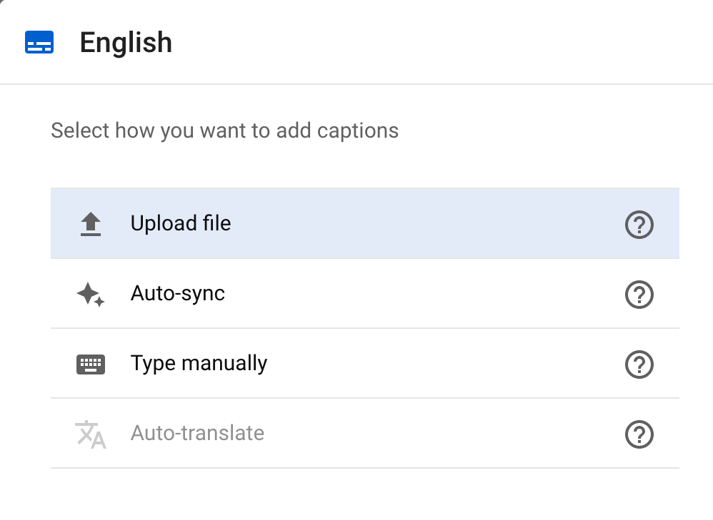

- Upload the transcript as a plain text (.txt) file. Using a Word document will not work properly. Preferably, use Notepad or any other similar application. Before uploading it, edit the file so as to include only what is actually said in the video, without bullet points, headers or footnotes.
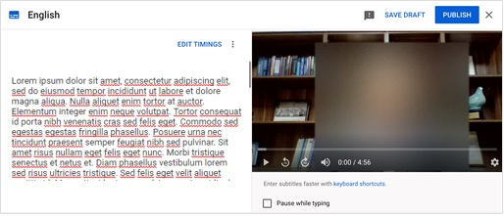
- The transcript will appear in the following box. Click on “Publish”.

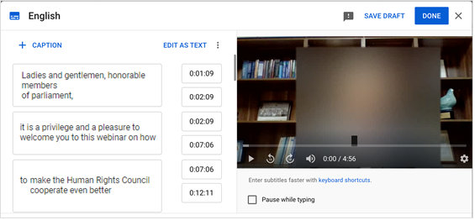
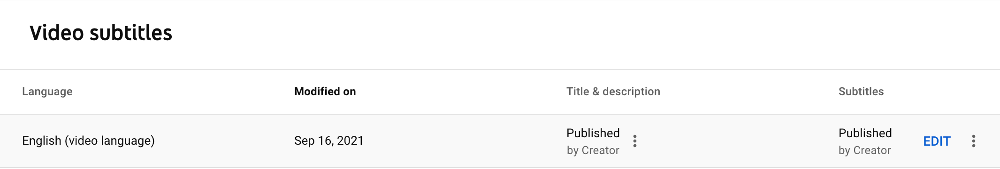
- YouTube will now transform the transcript in timestamped subtitles. For a 7-minute video, this takes 2 to 3 minutes on average. YouTube does not refresh the page automatically when this process has finished; so refresh the page after a few minutes to check whether it is finished (refreshing the page before it is complete does not reset the progress). When it is done, in “Video subtitles” section, click on “Edit" button to test and correct the captions and timing in accordance with the actual speech on the video.

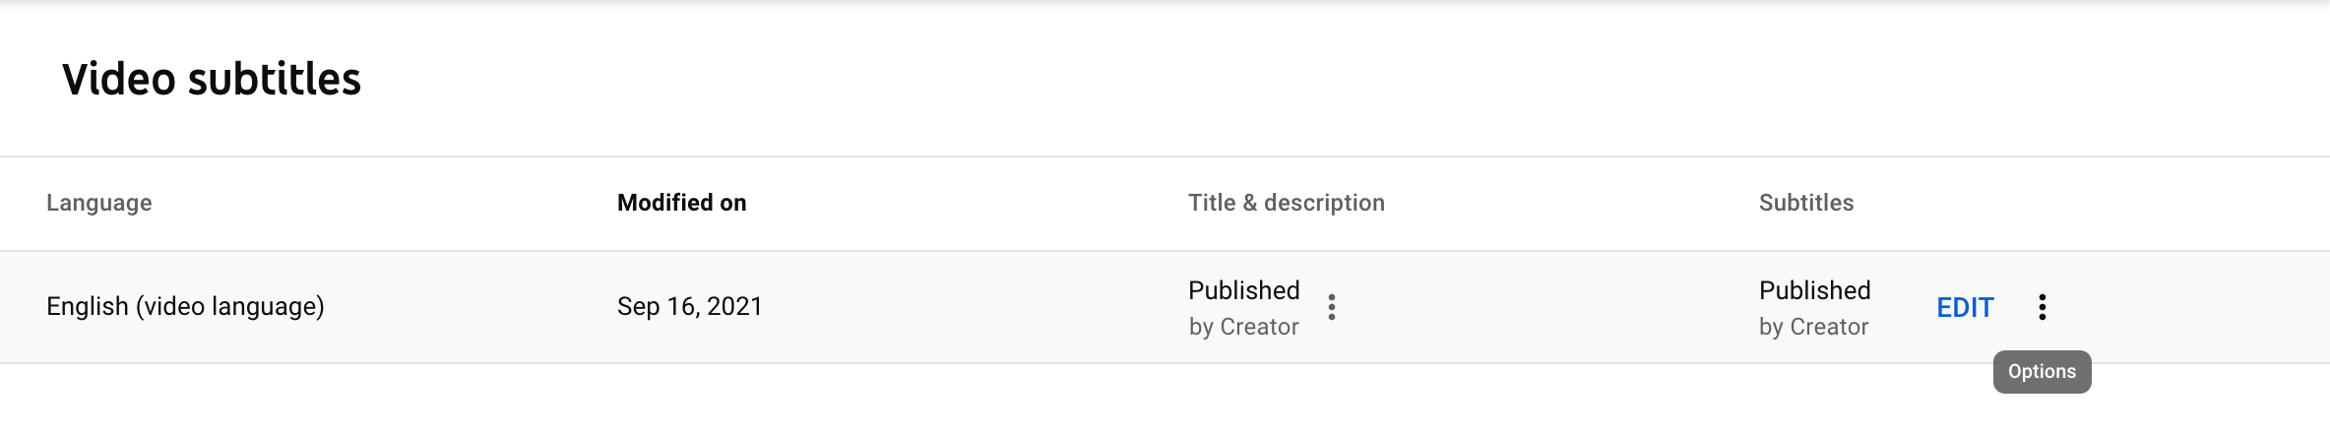
- After correcting the captions, press “Done" on the top-right corner, go back to the "Video subtitles” section and click on the three dots to access the options.
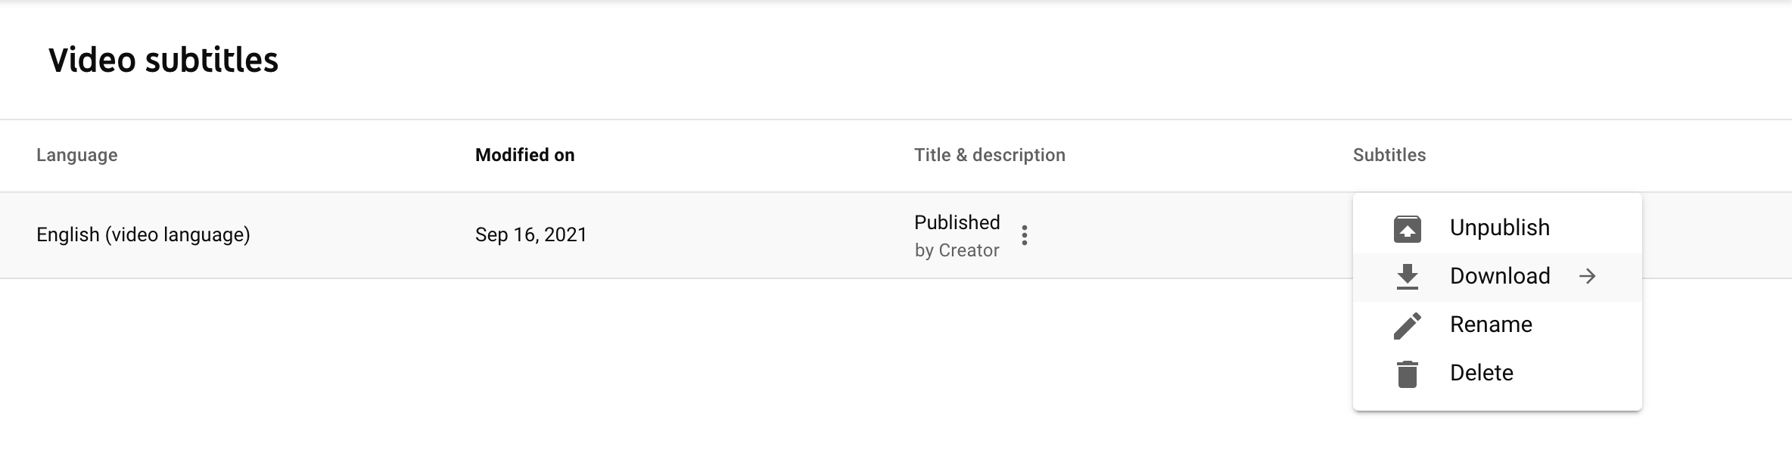
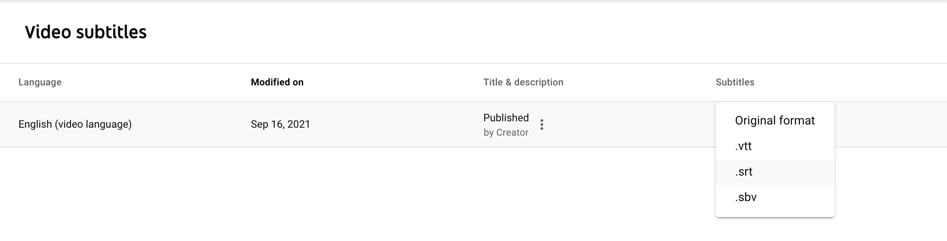
- In “Options”, select “Download" and click on .srt format from the dropdown menu. Save it with the same file name as the video.
- To test the subtitle file, open the video file using a player that supports subtitles, such as VLC Media Player. Provided that both files have the exact same name and are saved on the same folder, as in capture below, captions should be displayed automatically.
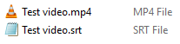

- Kindly upload the .srt subtitle file in the dedicated field when uploading the video and related files on Events (https://events.ohchr.org/.).

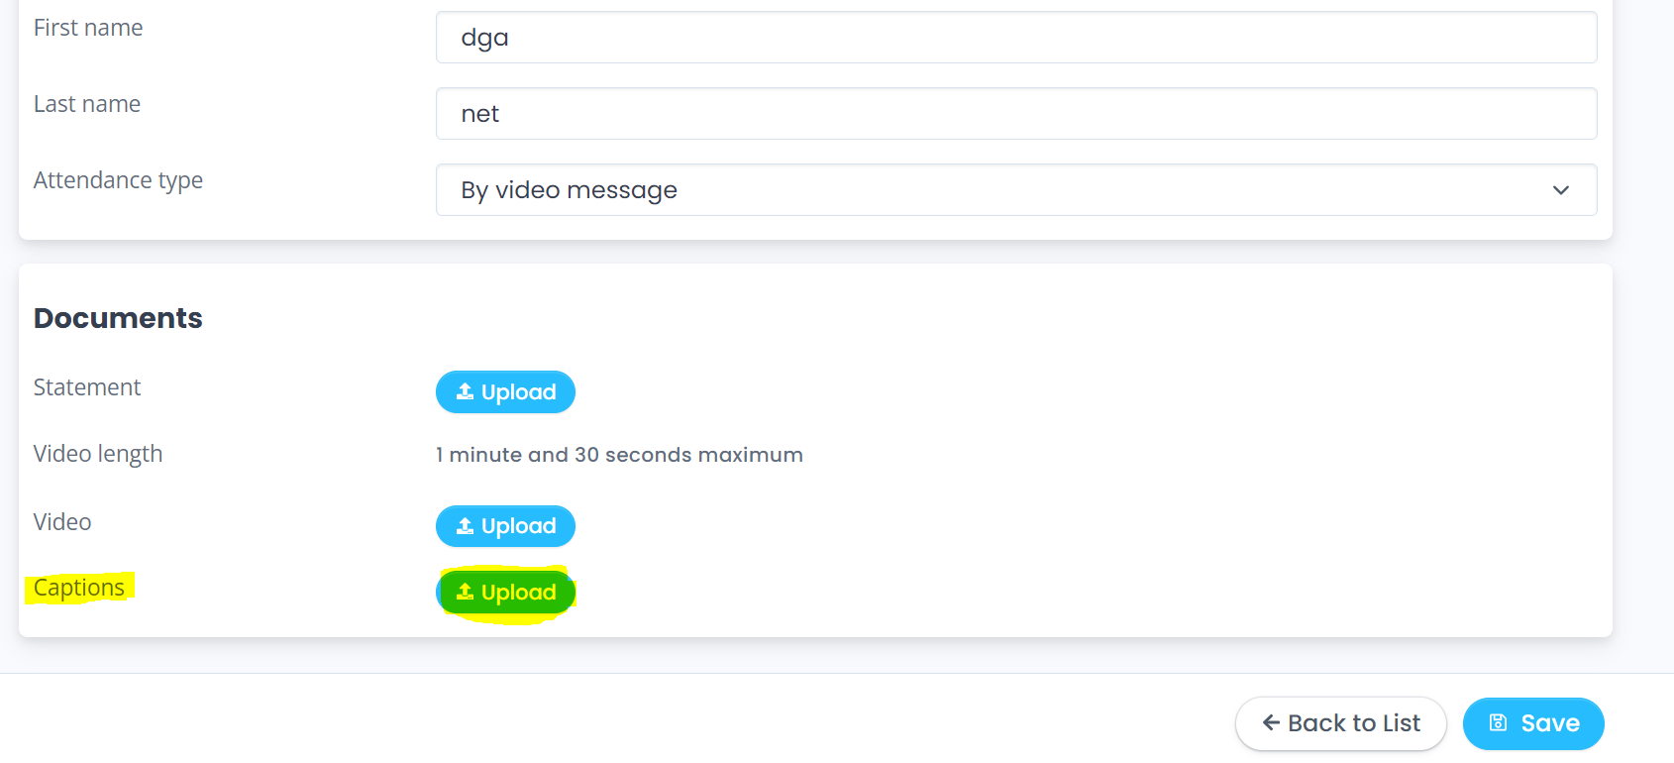

Microphones should reproduce audio frequencies between 125 Hz and 15,000 Hz, with a variation of maximum +/- 10dB. Microphones shall comply with IEC 60268-4.

