Guidance note on joint statements delivered

during the 62nd session of the Human Rights Council

- A joint statement is a statement supported by one or more States in addition to the one delivering it.*
- As per established practice, joint statements are given priority on the list of speakers: they are moved to the top of the list in the order of inscription.
- It is the responsibility of the State delivering the joint statement to provide the Secretariat with the list of supporting States prior to its delivery.
- The list of supporting States:
  - Needs to be indicated by the State delivering the statement at the time of inscription for the list of speakers via the Events inscription system (see Annex I for technical details);
  - Must not be an open-ended list, i.e. must not contain ‘and other States’;
  - Must correspond to the number of supporting States announced by the delivering State in its statement, i.e. ‘I am delivering this statement on behalf of XX delegations’;
  - The list may be updated directly by the delivering State until 2 weeks (21 July 2026) after the session on Events (see Annex II for instructions).
  - IMPORTANT – The session report will reflect the lists of supporting States as informed on Events and will not consider updated lists sent by email or as part of transcripts of oral statements.
- The Secretariat will not be in a position to register the inscription unless the above-mentioned requirements are met. The delivering State bears the sole responsibility for the States listed in the joint statement.
- The final list of supporting States is included in the report of the session adopted by the Council ad referendum on the last day of the session. After finalization, the report is distributed to all permanent missions for comments before being published on the webpage and the Extranet page of the relevant session.

ANNEX I. How to inscribe for joint statements on Events:
- If you wish to inscribe to speak on behalf of a group of States, select “Yes” at group registration.
- If you are inscribing to speak on behalf of a UN recognized group, select the group from the drop-down menu.
- If the group does not appear on this list, click on “Yes, create a custom group”
- Subsequently, select the countries in the group from the drop-down menu (minimum two countries including the one delivering the statement). These countries must correspond to those referred to in the statement.

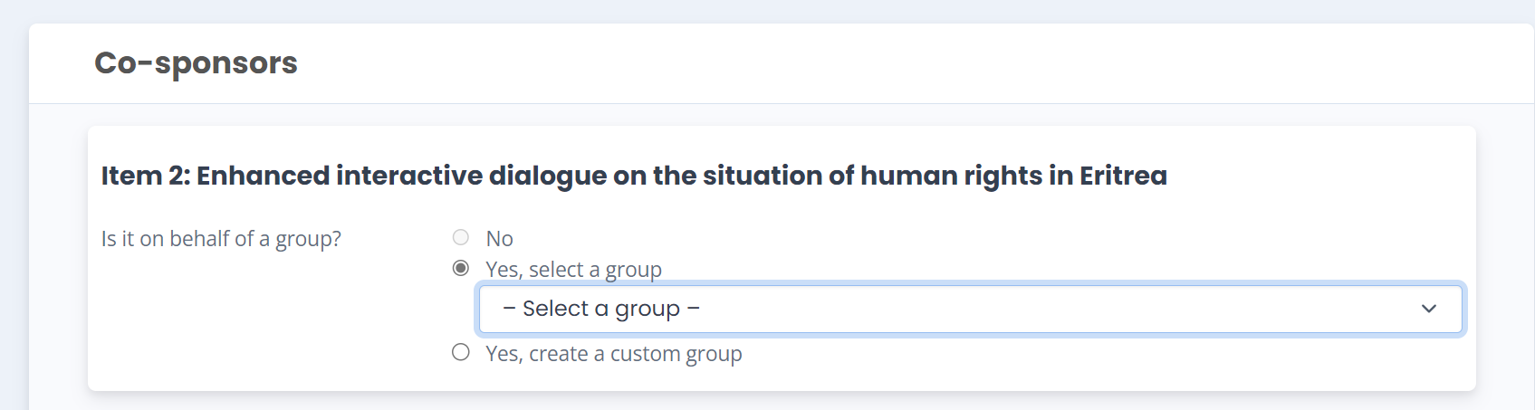
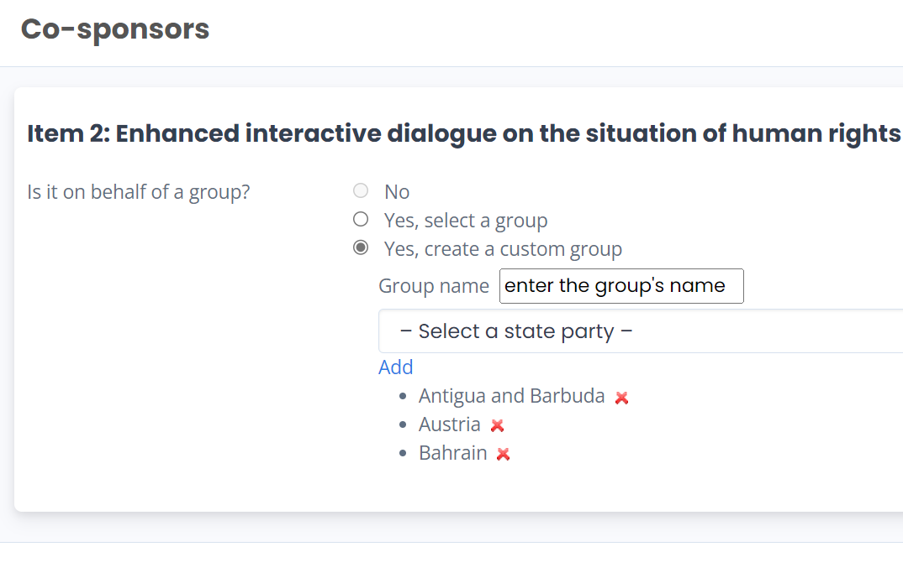
- Click ‘Save’ and the debate will appear in the window of inscriptions.
ANNEX II. How to update the list of supporting States of a joint statement on Events

- On the page of inscription on the list of speakers, go to the bottom of the page. You will see the joint statements you intend to deliver.
- Click on “Edit” and edit your list of supporting States.

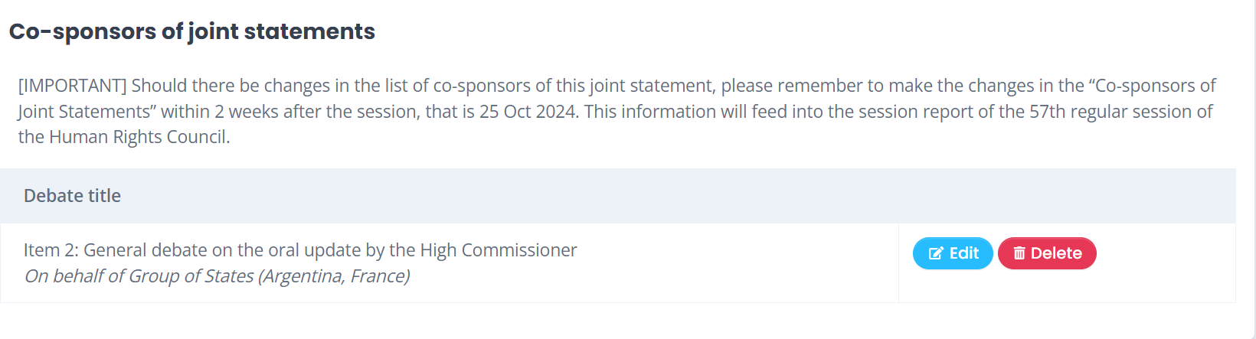

* This guidance note is intended for States Members of the Human Rights Council, observer States, United Nations entities, specialized agencies and related organizations.

