Human Rights Council
62nd regular session (15 June – 7 July 2026)
REQUIREMENTS FOR E-TABLING OF DRAFT PROPOSALS
(as of 12 June 2026)

A. Recurrent texts
Recurrent draft resolutions must be based on the previously adopted text as officially issued in the Official Document System of the United Nations (ODS) at https://documents.un.org.
The final, edited text of the previously adopted resolution as officially issued has the following symbol A/HRC/RES/session number/resolution number (for example, A/HRC/RES/43/12).
In no circumstances will the Secretariat accept for processing a draft proposal based on a previous “L document”, i.e., the draft preceding a previously adopted resolution that had not been edited after adoption (for example, A/HRC/43/L.12).
Main sponsors can download from the Official Document System (ODS) the Word version of the previously adopted resolution, as officially issued with the symbol A/HRC/RES/xx/xx (as shown below):
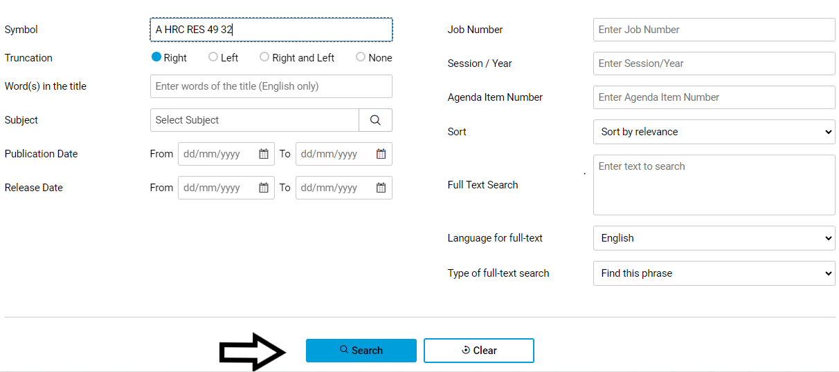
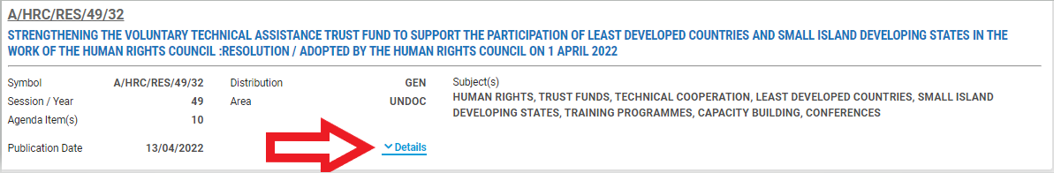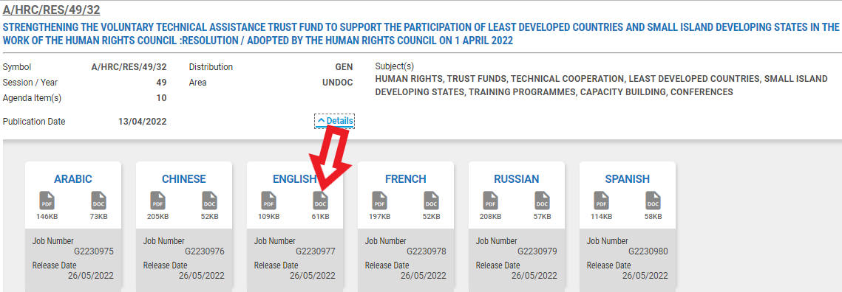
Once the sponsors have downloaded the previously adopted resolution, as officially issued, they must use the function Track Changes in the Word document so that all deletions or additions are clearly indicated in the text that they submit.
TIP: HOW TO TRACK CHANGES IN WORD
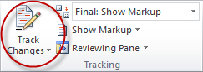
▪ Search for previously adopted resolution as officially issued on the United Nations Official Document System (ODS) at https://documents.un.org, download the Word version and save it as a new document;
▪ On the tools menu, choose the “Track Changes” option to open the Reviewing toolbar;
▪ Turn on Track Changes option by clicking the icon and make changes onto the document;
▪ Any changes to the original text will now be visibly indicated in the document.
When the text is ready in the format Track Changes, delegations must:
- Upload the file in e-deleGATE (https://e-delegate.un.org) clearly indicating “Tabling version”;
- Send an email to ohchr-hrctabling@un.org with the name of the proposal in the subject line and stating that the file is uploaded in e-deleGATE and ready to be tabled;
- Remain at the disposal of the Secretariat and the editors to reply to any urgent query, given the short turnaround time between submission and issuance of the L. document.
The Secretariat will:
- Acknowledge receipt of the submission email, which is used to certify the time of the submission prior to the deadline of Thursday, 25 June 2026, 1 p.m. Geneva time.
The submission of a proposal after the submission deadline needs prior approval by the Council before it is registered by the Secretariat. NO DRAFT PROPOSAL WILL BE ACCEPTED AFTER THE TABLING DEADLINE unless an extension is requested in writing to the Secretariat by 12 (noon) on Thursday, 25 June 2026 and subsequently granted by the Human Rights Council before 1 p.m. Any requests for extension should be explained and communicated in advance of the tabling deadline to the Secretariat to allow sufficient time to inform the President, who will decide on the course of action. An extension of the deadline for the submission of a draft proposal can be approved by the Human Rights Council under exceptional circumstances, one time only, for a maximum of 24 hours.

- Download the tabled version from e-deleGATE, register the draft proposal and attribute to it an L number (example: A/HRC/62/L.1);
- Send a subsequent email to confirm that the files attached are in compliance with the submission guidelines;
- Return to the submitter all submission files that are not in compliance with the guidelines, in particular texts not based on previously adopted texts as officially issued in the ODS or not in Track Changes.

B. New draft proposals
For completely new draft proposals, no text needs to be marked up in electronic track changes. However, the source of agreed language must be reflected in parenthesis after relevant paragraphs to facilitate the editing and processing of the text.

Unless the recurrent draft resolution has a completely new focus, which significantly changes the text of the previously adopted resolution. In such a case, please contact the secretariat well in advance of the tabling deadline to clarify this.

