UNITED NATIONS HUMAN RIGHTS COUNCIL

62nd session (15 June – 7 July 2026)

Guidance note on inscribing on the list of speakers and uploading statements on the HRC Extranet

This guidance note is intended for States Members of the Human Rights Council, observer States, United Nations entities, specialized agencies and related organizations. Please refer to a separate guidance note for uploading video messages. National human rights institutions and non-governmental organizations are invited to refer to the information available on the HRC website.
Contents
Accessing the EVENTS platform 2
Editing your profile 5
Accessing the HRC 62nd session: 6
Inscription dates and deadlines 6
Inscribing on the lists of speakers 6
Uploading statements 8
Online inscription for panel discussions 9

The Human Rights Council will use the Events platform. The online system can be accessed through https://events.ohchr.org/
The online system for inscription on the list of speakers will be used for interactive dialogues, general debates, panel discussions and UPR adoptions.

Accessing the EVENTS platform
- Creating a primary account

- Recommended browsers are Microsoft Edge and Google Chrome.
- Only one account can serve as a primary account holder. It is recommended that the primary account is created by using the generic email address of the Permanent Mission, UN agency or intergovernmental organization. This will avoid potential disruptions caused by staff turnover.
- To access Events, please click on the following link: https://events.ohchr.org/
- All Permanent Missions should already have a primary user account on Events since they were transferred from the old system.
- To access Events, please use the same credentials used for the 61st session of the Council.
- If your email is not registered, the system will automatically let you know. In this case, please contact ohchr-hrclistofspeakers@un.org for assistance.
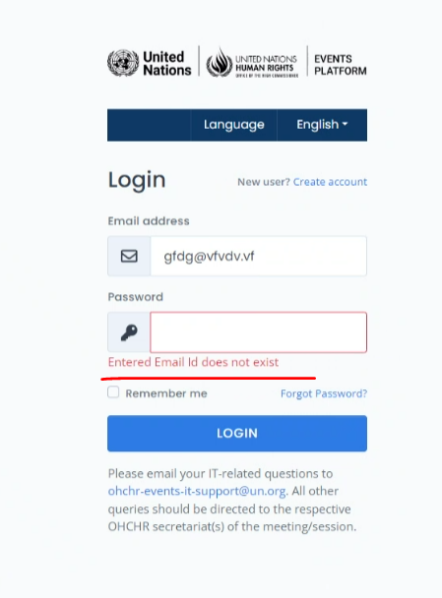
- Please note that intergovernmental organizations and UN agencies that participated in the last Council session should already have a primary account that they can use for this session. If not, they will have to create a new account by clicking on the “create account” button.
- If you are facing any technical difficulties in accessing your account or changing your password, please write to: ohchr-events-it-support@un.org copying ohchr-hrclistofspeakers@un.org and attach a screenshot of the error.

- Creating and verifying secondary accounts

- The primary account holder will have the authority to approve a maximum of four secondary user accounts.
- Only primary accounts can make an inscription to the list of speakers. The secondary accounts can only be used to make changes to an existing inscription, i.e. to add information or remove a speaker from the list.
- If you wish to create a secondary account, please click on “create account” and follow the steps. You may remind the primary account holder to verify your request.
- If you are a primary account holder, you will have the authority to verify requests for secondary accounts. When a new user attempts to create a secondary account, you will receive an email notification. At this point, you may login using your primary account. You will see the pending requests for verification.

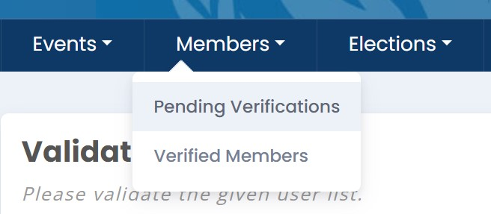
- Click on ‘pending verifications’:

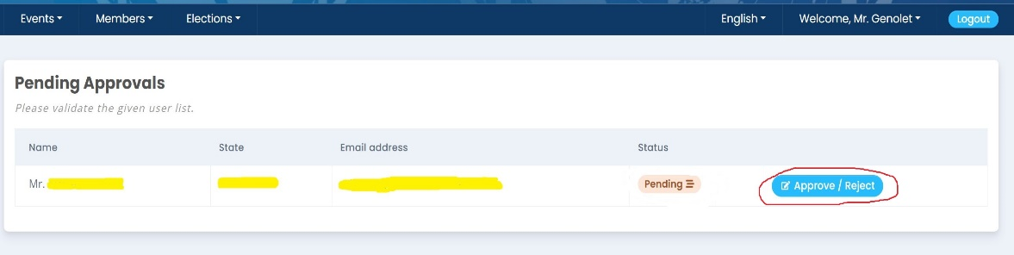
- Click on the ‘approve/reject’ button:

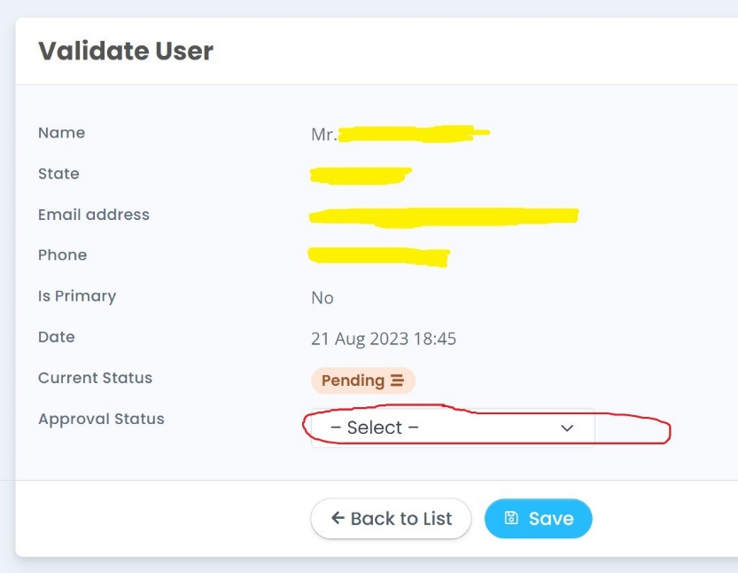
- Click on ‘select’ drop down list at the approval status:

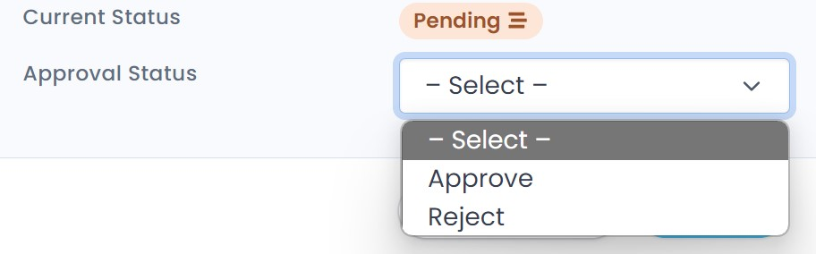
- Select the approve or reject option and save.

Editing your profile
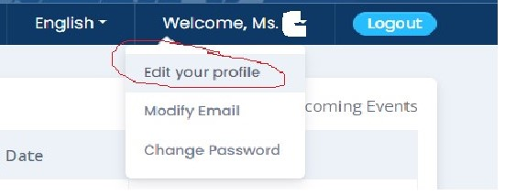
- All primary and secondary account holders can change their profile information by going to the welcome screen and clicking on ‘edit your profile’:

- Change your information and click on ‘save’

- You can change your email by clicking on “modify email”. Insert your new email.

- You will receive a confirmation email on your new email address. Click on the email link and type the password to confirm your new email.

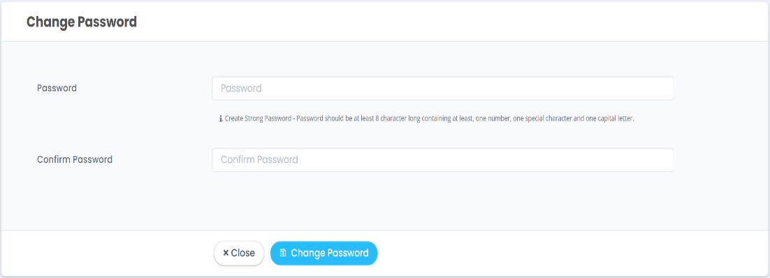
- You can also change your password when logged in by clicking on “change password”:

- Enter the password two times (confirm password) and observe the password complexity requirements:
- Click “change password” or contact ohchr-hrclistofspeakers@un.org for further assistance.

Accessing the HRC 62nd session:
- Once successfully logged in, a list of events will appear on your welcome screen.
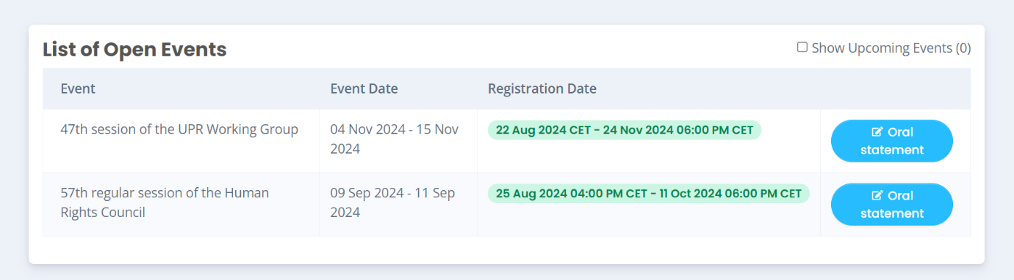

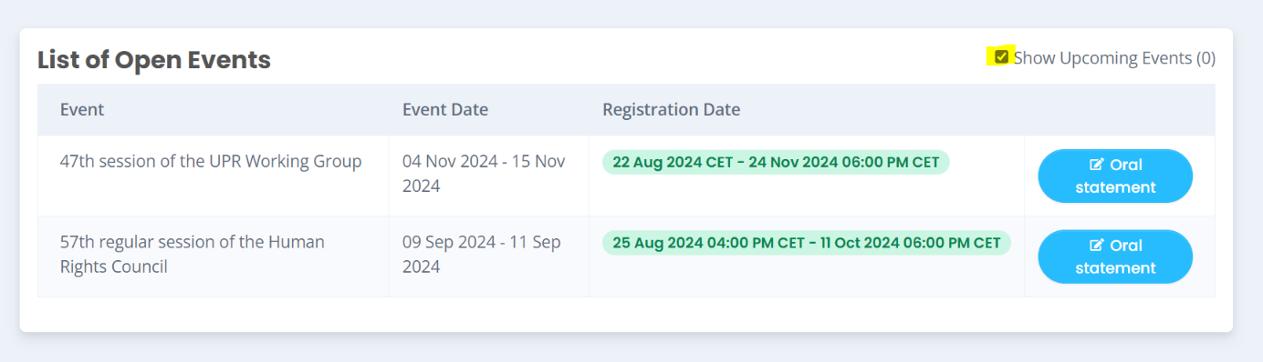
- If you do not see an event, select ‘show upcoming events’ on the right corner to see the upcoming session.

Inscription dates and deadlines
For all interactive dialogues, general debates and panel discussions, the online inscription for the lists of speakers will open on Tuesday, 9 June 2026 at 10 a.m. and will close 2 hours before the meeting in which the respective debate is scheduled to start.
In exceptional cases, after the online inscription has closed, delegations may still inscribe or withdraw by sending an email to ohchr-hrclistofspeakers@un.org.
In line with the measures adopted at the Organizational Meeting on 1 June 2026, all interactive dialogues will be limited to 1 hour and 30 minutes, with 1 hour dedicated to interventions by States.

Inscribing on the lists of speakers
          - From the list of open events, go to the 62nd session of the Human Rights Council. Click on “Oral statement”

          - Click on “+ Register to a debate”
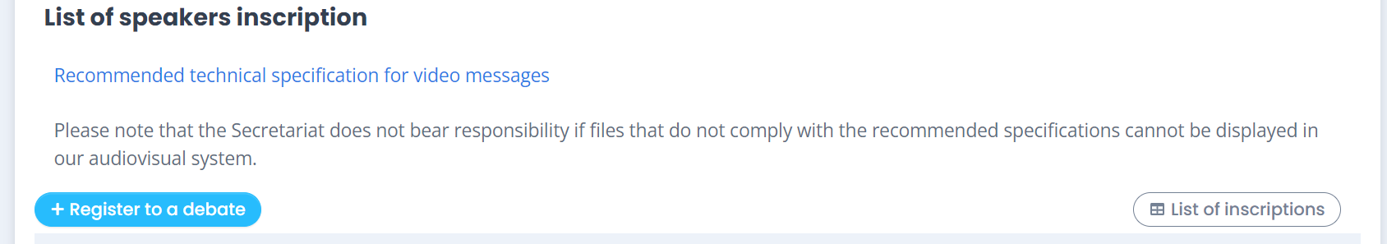
          - Select the debate type, title, priority and mode of participation. Follow the steps and then click “save”. Please note that if you have selected attendance in person, the option for uploading videos will not be available in the next steps.

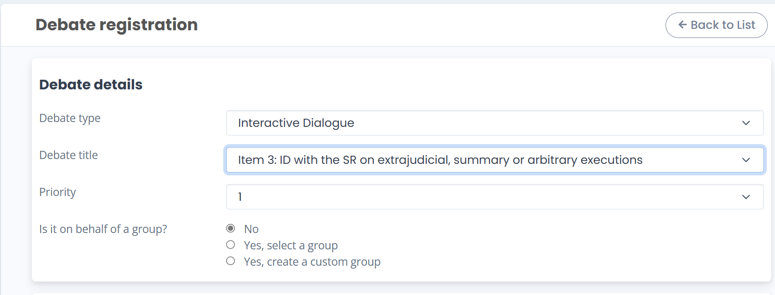

          - Delegations will be asked to rank the interactive dialogues they wish to intervene in according to their order of priority. The system will allocate speaking slots based on the priorities submitted. The system does not allow participants to set the same level of priority for more than one dialogue. Please also note that you are not required to select a priority if the statement is made on behalf of a group. No priority rank is required for the general debates, and the speaking time will be 1 minute and 30 seconds for all.

          - Please note that interactive dialogues and panel discussions are managed under separate priority tracks. This means a delegation may select priority 1 for an interactive dialogue and priority 1 for a panel discussion without conflict.

          - While the system aims to accommodate as many States as possible based on their highest priority (priority 1), there may be cases where the number of delegations selecting a particular dialogue as priority 1 exceeds the number of speaking slots available. When this occurs, the system will no longer allow further inscriptions at priority 1 for that dialogue. Delegations attempting to inscribe at that point will receive the following automated message: “Due to the high number of inscriptions for this debate, it is no longer possible to select a preference of priority 1. You may still inscribe to this debate but by choosing a different priority. The list of speakers will be based on available slots, selected priority, and time of inscription, with a spill-over list if time permits.”
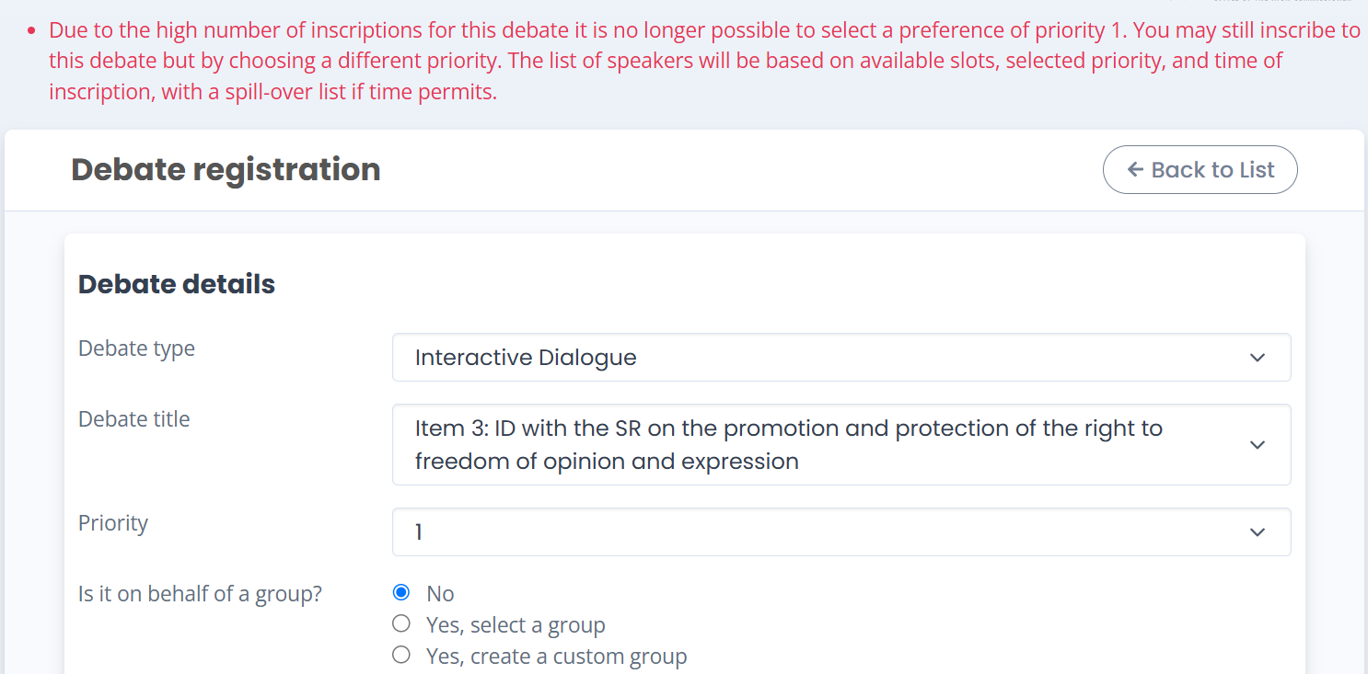

- In such situations, delegations are encouraged to re-rank the dialogue under a different priority. The allocation of speaking slots will then be determined according to the newly selected priority and the time of inscription.
- Upon successful inscription, you will receive an automatic confirmation email.
- If you do not receive a confirmation email, please inform the Secretariat at: ohchr-hrclistofspeakers@un.org .
- Click on ‘back to list’ and you will be directed to a page showing the list of all debates you have inscribed to, as well as the priority selected and the attendance type. You may enter the speaker’s name and modify any of the information provided for each debate by clicking on “Edit”.
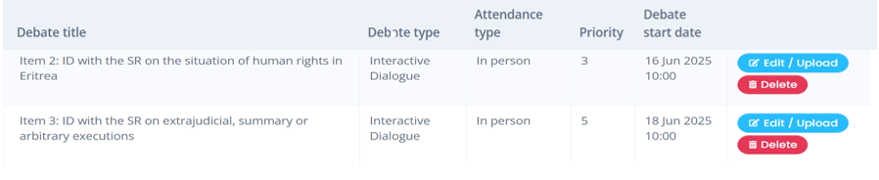
Please note: It is not possible to edit the selected priority. If you wish to change the priority, you must delete the inscription and submit a new one.

- You may also withdraw from a list of speakers by clicking the “Delete” button on the same page. This option will be deactivated once the online inscription closes. After that point, any withdrawal requests must be sent by email to: ohchr-hrclistofspeakers@un.org.

Uploading statements
In order to facilitate interpretation, all participants/speakers are requested to upload their oral statements through the online inscription system https://events.ohchr.org/ before the start of the debate or dialogue in question, including, wherever possible, for the right of reply and voting.
These statements can later be replaced with final versions that can be posted on the Extranet.
- Statements should be uploaded in Word format only.
- Uploaded statements will be forwarded automatically to UNOG meeting service assistants for interpreters. They will be posted on the Extranet after they have been delivered unless the delegation alerts the secretariat in advance that the final/revised version will be sent later for posting on the Extranet.
- The final version should be uploaded online as soon as possible.
- If, for some reason, it is not possible to upload the statement through the online system, it can be submitted by email to ohchr-hrcstatement@un.org and msu2@un.org.

- On the registration page, you will see an “edit” button, as in the previous screenshot. After clicking on it, you will see a new dialogue box where you can upload the written statement (in word format), the video statement (if applicable), and the captions.
- You are strongly encouraged to upload your written statement as early as possible before the selected debate.
- For recording video statements and creating captions, please follow the steps provided in a separate guidance note.
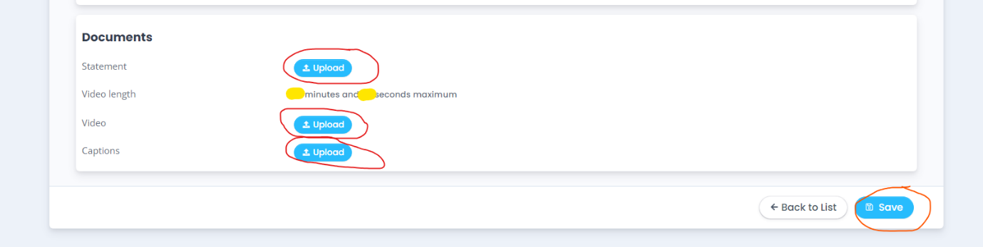
- After preparing your written and/or video statement, click on the ‘upload’ button then click on ‘save’:

- You will be able to upload a video statement up to 2 hours before the start of the selected debate.
- You will not be able to see the function for uploading a video unless you have selected the mode of attendance “by video”.

Online inscription for panel discussions
During this session, the list of speakers for each panel discussion will be generated by the system based on the indicated priority and the time of inscription, thus allowing a broader representation of delegations participating in panel discussions over the course of the session. In registering for a panel discussion, delegations will be requested to select a priority (1, 2, 3…) in a drop-down list for each panel.

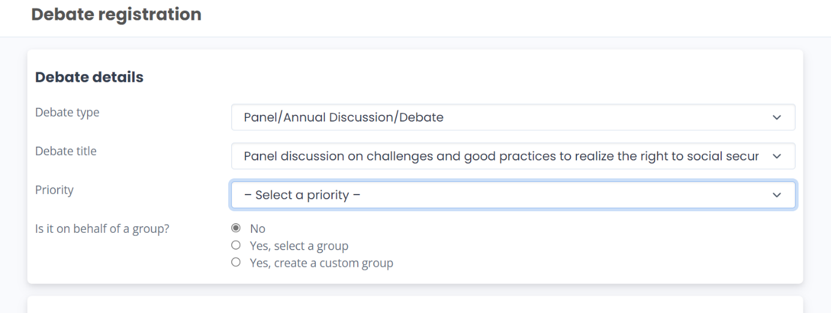

The system does not allow participants to set the same level of priority for more than one panel.
Please note that interactive dialogues and panel discussions are managed under separate priority tracks. This means a delegation may select priority 1 for an interactive dialogue and priority 1 for a panel discussion without conflict.

