Human Rights Council
62nd regular session (15 June – 7 July 2026)

GUIDELINES ON DRAFT PROPOSALS:

SUBMISSION AND CO-SPONSORSHIP
(as of 12 June 2026)

Deadline for the submission of draft proposals: Thursday, 25 June 2026, 1 p.m. Geneva time by uploading the text in e-deleGATE and sending an email to ohchr-hrctabling@un.org
Deadline for the submission of original (early) co-sponsorships: Thursday, 25 June 2026, 1 p.m. Geneva time in e-deleGATE (https://e-delegate.un.org)
Please note that paper signature forms for co-sponsorship are no longer used

Contact person for tabling draft proposals (designated receiving officer) and
for processing of resolutions: Ms. Meena RAMKAUN (office A-646, tel. 022 917 9724 and 076 343 4777 (mobile in use only during the session), email: meena.ramkaun@un.org)
Contact persons for PBIs and processing of resolutions: Mr. Akhil ABRAHAM (office A-646, email: ohchr-hrctabling@un.org), Mr. Matias PELLADO (office A-646, email: ohchr-hrctabling@un.org)

The following information will be made available on the Extranet for the 62nd regular session:
- The present Guidelines on draft proposals: submission and co-sponsorship
- Requirements for e-tabling of draft resolutions
- Guidelines for main sponsors: initiating a draft resolution for sponsorship in e-deleGATE
- Guidelines for co-sponsors: how to co-sponsor a draft resolution in e-deleGATE
- Resource requirements for human rights mandates – PBI explanations and examples
- Note on editing of draft proposals at the Human Rights Council
- Standard voting procedure (English and French)
- Information on draft and adopted proposals
  - Main sponsor(s) of a draft proposal
  - Draft proposal as received (i.e., as formally submitted, no formatting)
  - Draft proposal as officially issued (“L” document with symbol A/HRC/62/L…) and revisions if applicable
  - PBI (Programme budget implications) statement, if applicable and when received
  - Result of the vote, if applicable

Draft proposals at the Human Rights Council

Three types of proposals are considered by the Human Rights Council:
- draft resolution
- draft decision
- draft President’s statement (PRST).

According to United Nations Secretariat practice, decisions (normally comprising one or two paragraphs, without any preamble) are reserved for procedural matters (for example, see Council decisions 31/116, 24/115 or 26/115), while resolutions concern substantive (i.e., in the case of the Council, human rights) matters.

[see separate note on editing for the layout of draft resolutions and decisions]

Before submission

Consultation process

Before action is taken, and in accordance with paragraph 113 of the annex to Human Rights Council resolution 5/1, a draft proposal should be the object of at least one informal open-ended (i.e., public) consultation with other delegations before it is considered for action by the Council.

Public informal consultations should be announced in the Sched meeting application, which replaces the daily Bulletin of informal meetings.

You may contact the Secretariat:
- To seek advice on the functioning of the Human Rights Council e-Sponsorship platform in e-deleGATE
- To request information on possible programme budget implications (PBIs) of the draft proposals
- To seek advice on editorial requirements
- To give advance warning if a draft proposal may be particularly lengthy so as to facilitate planning of editing and translation services accordingly
- To obtain the final Microsoft Word version of relevant resolutions or decisions to use as a basis for a draft proposal or when submitting a subsequent in-session revision.

Initiating the draft proposal for co-sponsorship
The main sponsor must initiate the draft proposal through the Human Rights Council e-Sponsorship platform (https://e-delegate.un.org) before the Secretariat can register the draft proposal as formally submitted.
It is advised that the main sponsor initiate the draft proposal (i.e., open it for co-sponsorship to other delegations) as early as possible. The sponsor may replace the draft proposal (in the field “informal document”) as many times as necessary, clearly distinguishing the subsequent versions with recognizable file names (for example, zero draft; draft number 1; draft number 2).
Guidelines on how to initiate a draft proposal for co-sponsorship are available on the e-Sponsorship platform and on the HRC62 Extranet.
A draft resolution initiated for co-sponsorship in e-deleGATE is NOT yet considered as formally submitted and will NOT be formally registered by the Secretariat until the main sponsor sends an email to the Secretariat at ohchr-hrctabling@un.org to formalize the submission.

Technical requirements
1. All draft proposals should have a title and indicate the agenda item under which they are submitted (see annex for the list of agenda items). Once the draft proposal is formally registered, the agenda item cannot be changed.
2. When the draft proposal is submitted in more than one language, the sponsor should clearly indicate which language version is to be considered the original language and used as the basis for translation; the other language versions will be provided “for reference only” to the translators.
3. Recurrent draft resolutions must be based on the previously adopted text as officially issued in the Official Document System of the United Nations (ODS) at https://documents.un.org. The final, edited text of the previously adopted resolution as officially issued has the following symbol A/HRC/RES/session number/resolution number (for example, A/HRC/RES/43/12).

In no circumstances will the Secretariat accept for processing a draft proposal based on a previous “L document”, i.e., the draft preceding a previously adopted resolution that had not been edited after adoption (for example, A/HRC/43/L.13).
Main sponsors can download from the Official Document System (ODS) the Word version of the previously adopted resolution, as officially issued with the symbol A/HRC/RES/xx/xx (as shown below):
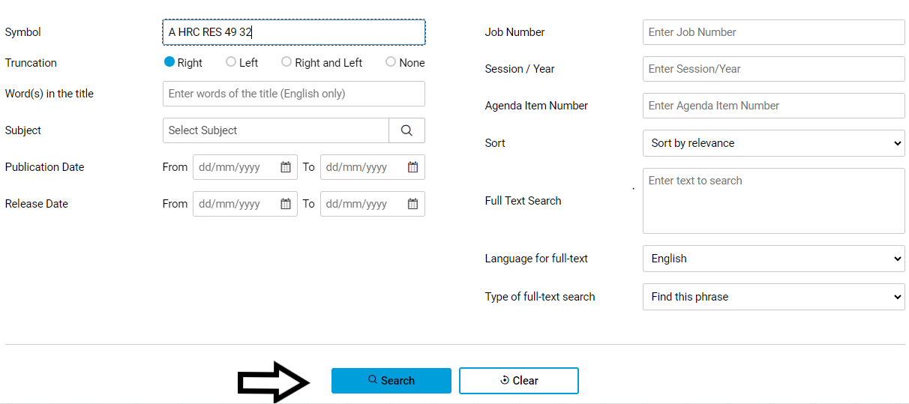
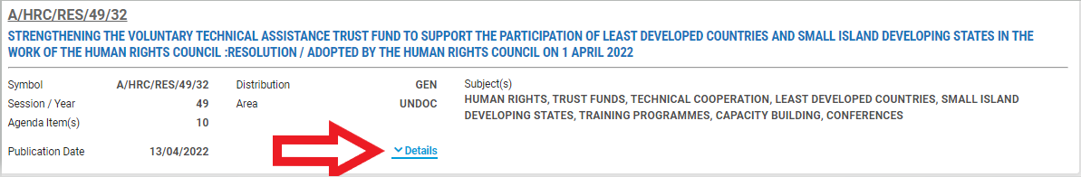
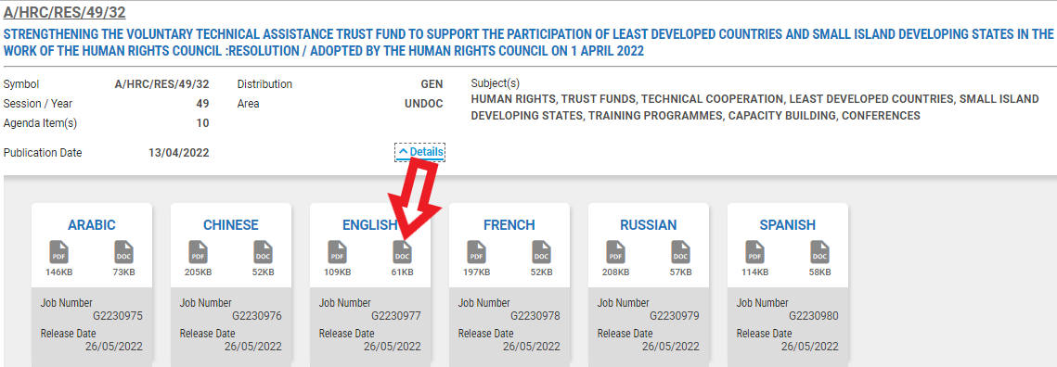
Once the sponsors have downloaded the previously adopted resolution, as officially issued, they must use the function Track Changes in the Word document so that all deletions or additions are clearly indicated in the text that they submit.

TIP: HOW TO TRACK CHANGES IN WORD
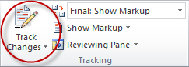
▪ Search for previously adopted resolution as officially issued on the United Nations Official Document System (ODS) at https://documents.un.org, download the Word version and save it as a new document;
▪ On the tools menu, choose the “Track Changes” option to open the Reviewing toolbar;
▪ Turn on Track Changes option by clicking the icon and make changes onto the document;
▪ Any changes to the original text will now be visibly indicated in the document.

During submission

Time of submission
Proposals should be submitted as soon as possible, prior to or by the deadline, in order to allow time for editing, processing and translation of the document. Early submissions are strongly encouraged.
- The submission of a proposal after the submission deadline needs prior approval by the Council before it is registered by the Secretariat. NO DRAFT PROPOSAL WILL BE ACCEPTED AFTER THE TABLING DEADLINE unless an extension is requested in writing to the Secretariat by 12 (noon) and subsequently granted by the Human Rights Council before 1 p.m. Any requests for extension should be explained and communicated in advance of the tabling deadline to the Secretariat to allow sufficient time to inform the President, who will decide on the course of action. An extension of the deadline for the submission of a draft proposal can be approved by the Human Rights Council under exceptional circumstances, one time only, for a maximum of 24 hours.

Means of submission
When the main sponsor(s) are ready to table a draft proposal, they should:
- Upload the file in e-deleGATE (https://e-delegate.un.org) clearly indicating “Tabling version”
- Send an email to ohchr-hrctabling@un.org with the name of the proposal in the subject line and stating that the file is uploaded in e-deleGATE and ready to be tabled (no need to attach the file again to the email)
- Remain at the disposal of the Secretariat and the editors to reply to any urgent query that may arise, given the short turnaround time between submission and issuance of the L. document.
Main sponsor(s) contact person: The name(s) and contact details including a direct phone number and/or mobile phone number and an email address of the main sponsor(s) should have already been clearly indicated in e-Sponsorship platform. If this is not the case, this information must be provided to the Secretariat at this stage for ease of further communication with the Secretariat and editors.

Original co-sponsors: Only the main sponsors and all those delegations that have co-sponsored the draft resolution through e-deleGATE before 1 p.m. (Geneva time) on the date of the tabling deadline will appear on the first page of the officially issued draft proposal (“L” document). After this deadline, all others will be considered additional co-sponsors. No co-sponsorships are accepted for President’s statements, which are submitted by the President on behalf of the entire membership of the Human Rights Council.

After submission
Additional sponsors: All other delegations wishing to co-sponsor the proposal after the tabling deadline will be considered additional co-sponsors and listed as such in the report of the session (to be finalized after the session). During the session, after the proposals have been formally submitted, and after the session, once the resolutions have been adopted, delegations wishing to co-sponsor them can continue to do so through e-deleGATE.
- Additional co-sponsors may be recorded until two weeks after the conclusion of consideration of all draft proposals, i.e., until Tuesday, 21 July 2026 at 6 p.m. (Geneva time), when the Human Rights Council e-Sponsorship for the 62nd session on e-deleGATE will close. All recorded co-sponsorships will be reflected in the final report on the 62nd session of the Council (future document A/HRC/62/2).

First editing and translation: Please note that all draft proposals will be subject to editing. Draft proposals are edited in accordance with the rules and guidelines described in the United Nations Editorial Manual to make them clear, accurate, consistent and easy to read and understand. During this stage, the editor or the Secretariat may contact the main sponsors if any clarifications are needed. Afterwards, the document will be translated into the other official languages of the United Nations.

Written revisions: Any change to the submitted proposal made by the sponsors (i.e., a revision) must be based on the official document as issued, which has already been edited by the United Nations (i.e., “L” document with the United Nations logo) and not on the basis of the unedited version as received previously by the Secretariat from the sponsor. The officially issued “L” document can be downloaded from the HRC62 Extranet or obtained from the Secretariat. All changes should be clearly marked in Track Changes mode. The main sponsors are requested to submit the written revisions by uploading the text on e-deleGATE and sending an email to ohchr-hrctabling@un.org. The deadline for submission of written revisions is Wednesday, 1 July 2026, at 11 a.m. (Geneva time). No written revisions will be processed after the deadline and they will have to be made orally during the consideration of the proposal. If the changes in the draft proposal are minimal, please note that the Secretariat may recommend posting oral revisions on the HRC Extranet instead of processing the written revision as a new official document. This saves costs and time because the draft proposal does not go through a second round of editing, translation, printing and issuance as an official United Nations document.

Written amendments: Any changes by other delegations that are not acceptable to the sponsors (i.e., an amendment) are considered as a new proposal and must also be initiated as a new draft proposal through the Human Rights Council e-Sponsorship platform according to the same modalities as detailed above in the section “Before submission”, subsection “Initiating the draft proposal for co-sponsorship”.
The main sponsors of amendments should title their amendments on e-deleGATE as “Amendment to draft resolution A/HRC/62/L.X”. All amendments must be made with reference to the official document as issued, which has already been edited by the United Nations (i.e., “L” document with the United Nations logo) and not on the basis of the unedited version of the draft proposal. The officially issued “L” document can be downloaded from the HRC62 Extranet or obtained from the Secretariat.
The deadline for submission of written amendments is Wednesday, 1 July 2026, at 1 p.m. (Geneva time). No written amendments will be processed as new official documents after the deadline, and they will have to be made orally during the consideration of the draft proposal.

Oral revisions / oral amendments: Should there be oral revisions (changes to the proposal made by the sponsors) or oral amendments (changes by other delegations not acceptable to the sponsors) to the submitted draft proposal after 11 a.m. (revisions) and 1 p.m. (amendments) on 1 July 2026, the text of the oral revision / oral amendment should be uploaded on e-deleGATE and the Secretariat should be informed by sending an email to ohchr-hrctabling@un.org as soon as possible before the consideration of the proposal. This is to inform the President of the Council before the adoption of the text, and to ensure posting it on the HRC Extranet to facilitate the work of the delegations, given that there will be no distribution of hard copies. Oral revisions / oral amendments should be made in Track Changes to the official “L” document as issued, available on HRC62 Extranet or from the Secretariat upon request. The document will be marked in the masthead as “ORAL REVISION” or “ORAL AMENDMENT” and bear the date of submission to the Secretariat.

TIP: HOW TO TRACK CHANGES IN WORD
▪ Locate the officially issued draft resolution or L.doc on the United Nations Official Document System (ODS) at https://documents.un.org, download the Word version and save it as a new document;
▪ On the tools menu, choose the “Track Changes” option to open the Reviewing toolbar;
▪ Turn on Track Changes option by clicking the icon and make changes onto the document;
▪ Any changes to the original text will now be visibly indicated in the document.

After adoption

Editorial checking: Following the adoption of the draft proposal, the Secretariat will add the resolution number, adoption date, meeting number and voting results if any, incorporate any oral revisions or amendments made at the time of adoption and the editor will check the text for consistency of language and references.

Issuance as a new official document: The final text, as adopted, will be issued after the session under the new document symbol A/HRC/RES/62/… (for resolutions), A/HRC/DEC/62/… (for decisions) or A/HRC/PRST/62/…. (for President’s statements).

The final version of the adopted text will be posted on the OHCHR resolutions web page for the 62nd session once all six language versions have been released on the Official Document System (ODS).

All final versions of the resolutions, decisions and President’s statements adopted at the session will also be compiled in the 2026 annual report of the Human Rights Council submitted to the General Assembly (future document A/81/53).

Annex

Agenda

Item 1 Organizational and procedural matters
Item 2 Annual report of the United Nations High Commissioner for Human Rights and reports of the Office of the High Commissioner and the Secretary-General
Item 3 Promotion and protection of all human rights, civil, political, economic, social and cultural rights, including the right to development
Item 4 Human rights situations that require the Council’s attention
Item 5 Human rights bodies and mechanisms
Item 6 Universal periodic review
Item 7 Human rights situation in Palestine and other occupied Arab
territories
Item 8 Follow-up to and implementation of the Vienna Declaration and
Programme of Action
Item 9 Racism, racial discrimination, xenophobia and related forms of intolerance: follow-up to and implementation of the Durban Declaration and Programme of Action
Item 10 Technical assistance and capacity-building

https://hrcmeetings.ohchr.org/HRCSessions/RegularSessions/62/Pages/resolutions.aspx
Sched HRC62 feature can be accessed using a web browser or by downloading the application for mobile devices from Google Play Store and Apple Store. The use of Sched HRC62 is free of charge. Creating a personal Sched account allows users to personalize their agendas and synchronize their calendars. For more information, please consult the Sched “Web Tour for Attendees”.
Please contact Ms. Laura Giardini (email: laura.giardini@un.org, tel. 022 917 9255) and Ms. Mini Kumar (email: mini.kumar@un.org, tel. 022 917 9155) to request the public announcement of your informal consultation in the online application “Sched”.
Unless the recurrent draft resolution has a completely new focus, which significantly changes the text of the previously adopted resolution. In such a case, please contact the secretariat well in advance of the tabling deadline to clarify this.
https://www.ohchr.org/en/hr-bodies/hrc/regular-sessions/session62/res-dec-stat
https://documents.un.org
See Human Rights Council resolution 5/1, annex, sect. V, B.

